NO COST EXTENSION PROCEDURES

When doing a No Cost Extension you will need to extend the end date and close date on the Award in the Award Management window. Extend end date and close date on all installments.

***PROJECT
(SoM only) For NIH P, U, and T grants, you must also adjust the
task end date to the extension date at the project level.

AWARD
End Date: Enter NCX end date.
Close Date: Enter NCX close date.

TABS
Installments:
End Date: Enter NCX end date.
Close Date: Enter NCX close date.
Report Button: Change the report end date or add a new report (if
applicable)
Description: Enter Comment—NCX & New Extension period (i.e.
NCX through 01/01/2011)

Go to Award Budgets, enter comments under Version Name & Description, and save changes.

Submit to Accountant for baseline review.

For SoM, Clinical Trials (“VA” award range) NCX

1. Follow the steps above
2. Run Report 235 (Look under “Monthly/Cum Payment Amount→ The last $ amount)
3. Match Oracle Budget to Receipts (from Report 235)
4. Submit and Baseline

For example:

Report 235

On Report 235, it is showing that the total received/payment amount from Sponsor is $7,050 on this report (see below for the report screen-shot).
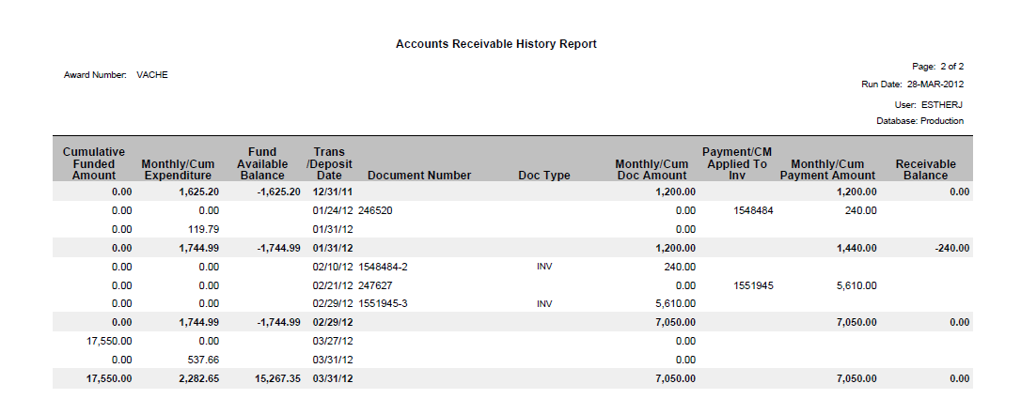

Therefore, go to Oracle Budgets and match Oracle Budgets to receipts of $7,050. In this example, this award previously had $1,200 under Oracle Budget, so the difference of $5,850 would need to be added to bring up to the current/new total of $7,050.

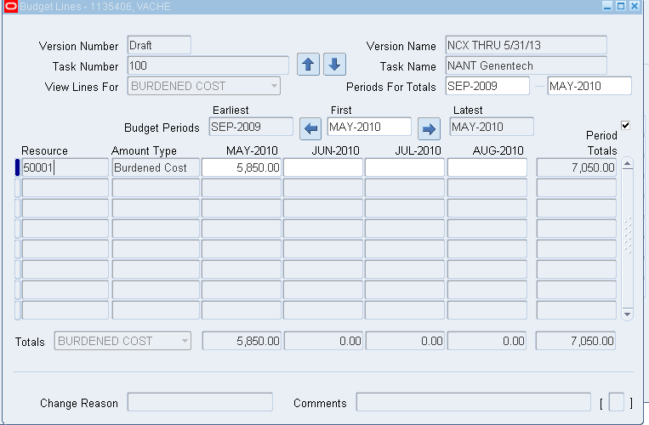

Submit and Baseline.

