EXHIBIT S-INTEREST AND EFP

When a sponsor requires interest to be accrued on their awards a second installment must be setup.

The sponsor must be on the following approved list:

- ABBOTT FUND
- ANDREW W. MELLON FOUNDATION
- BILL AND MELINDA GATES FOUNDATION
- CALIFORNIA ENDOWMENT
- CALIFORNIA HEALTHCARE FOUNDATION
- CALIFORNIA INSTITUTE FOR REGENERATIVE MEDICINE (CIRM)
- CARNEGIE CORPORATION (Some Not All Awards)*
- COMMONWEALTH FUND
- DORIS DUKE FOUNDATION
- GORDON AND BETTY MOORE FOUNDATION
- HOWARD HUGHES (HHMI) (Check with Linda for Interest)*
- JOHN D & CATHERINE T MACARTHUR FOUNDATION
- KAUST FOUNDATION
- KING ABDULLAH UNIVERSITY
- LEMELSON FOUNDATION
- PEW CHARITABLE FOUNDATION
- S D BECHTEL JR. FOUNDATION
- WM KECK FOUNDATION
- WILLIAM AND FLORA HEWLETT FOUNDATION

*Note: Check with Linda Erwin when in doubt.
**Compliance approval required if we do not have to report it on sponsor financial report form.

Task Setup

When setting up the project, in addition to the departments requested task(s) set-up two additional tasks (998 & 999):

  - Task Manager = Marilou Hemenway
  - Task Org = BZNB
  - Task Owner = President
  - Email Statement = No
  - Un-check the billable and allow charges boxes for both tasks.

After award is set up, budget and baseline 998 & 999 tasks at $0.

Award Setup

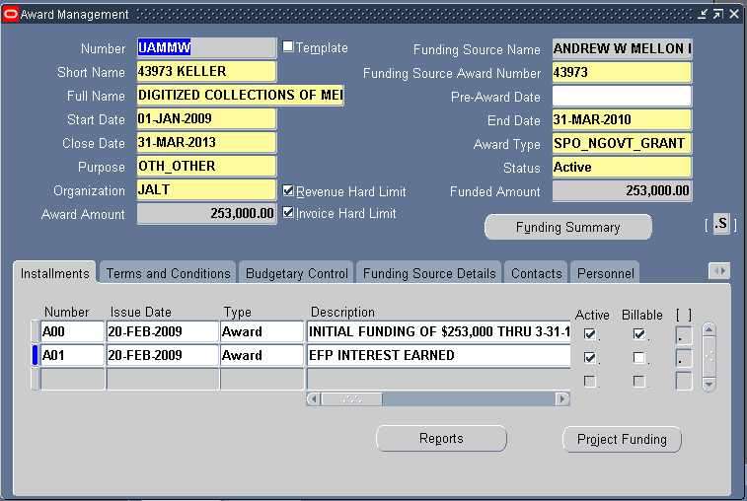

Step 1:
- Create a second installment with the same dates as the first. Type “EFP INTEREST EARNED” into the Description.
- DO NOT allocate funding to the installment.
- Fund the project for that installment at $0. The Research Accountants will fund accrued interest at a later date.
- The installment should be active but NOT BILLABLE. (Never code as billable because it will create a revenue entry on the GL.)

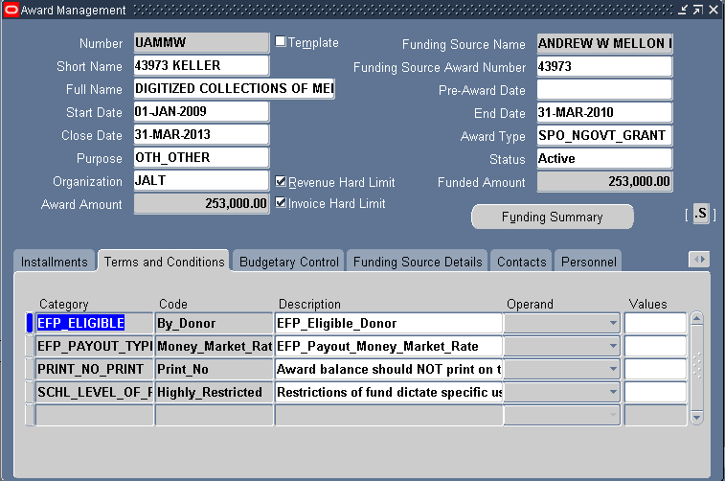

Step 2:
- Use the drop down boxes to select the above EFP_ELIGIBLE and EFP_PAYOUT_TYPE Category, Code, and Description.

**Note: EFP DOES NOT apply to cost-reimbursement contracts. Example: A grant from MacArthur Foundation would be required to accrue EFP. A contract from MacArthur Foundation which requires invoices for payment in arrears should not be coded to accrue EFP.**

