Definition and  ●  ○  ●  ●  ○  ○  Standard Symbol  Purpose | A stabilized construction access is defined by a point of entrance/exit to a construction site that is stabilized to reduce the tracking of mud and dirt onto public roads by construction vehicles.
Appropriate  Applications | - Use at construction sites:  - Where dirt or mud can be tracked onto public roads.  - Adjacent to water bodies.  - Where poor soils are encountered.  - Where dust is a problem during dry weather conditions.  - This BMP may be implemented on a project-by-project basis in addition to other BMPs when determined necessary and feasible by the Resident Engineer (RE).
Limitations | - Site conditions will dictate design and need.
Standards and  Specifications | - Limit the points of entrance/exit to the construction site.  - Limit speed of vehicles to control dust.  - Properly grade each construction entrance/exit to prevent runoff from leaving the construction site.  - Route runoff from stabilized entrances/exits through a sediment-trapping device before discharge.  - Design stabilized entrance/exit to support the heaviest vehicles and equipment that will use it.  - Select construction access stabilization (aggregate, asphaltic concrete, concrete) based on longevity, required performance, and site conditions. The use of asphalt concrete (AC) grindings for stabilized construction access/roadway is not allowed.  - Use of constructed/manufactured steel plates with ribs for entrance/exit access is allowed with written approval from the RE.  - If aggregate is selected, place crushed aggregate over geotextile fabric to at least 300 mm (12 in) depth, or place aggregate to a depth recommended by the RE. Crushed aggregate greater than 75 mm (3 inches) and smaller than 150 mm (6 inches) shall be used.  - Designate combination or single purpose entrances and exits to the construction site.  - Implement BMP SC-7, “Street Sweeping and Vacuuming” as needed and as required.  - Require all employees, subcontractors, and suppliers to utilize the stabilized construction access.  - All exit locations intended to be used continuously and for a period of time shall have stabilized construction entrance/exit BMPs (TC-1 “Stabilized Construction Entrance/Exit” or TC-3 “Entrance/Outlet Tire Wash”).
Maintenance and  Inspection | - Inspect routinely for damage and assess effectiveness of the BMP. Remove aggregate, separate and dispose of sediment if construction entrance/exit is clogged with sediment or as directed by the RE.  - Keep all temporary roadway ditches clear.  - Inspect for damage and repair as needed.

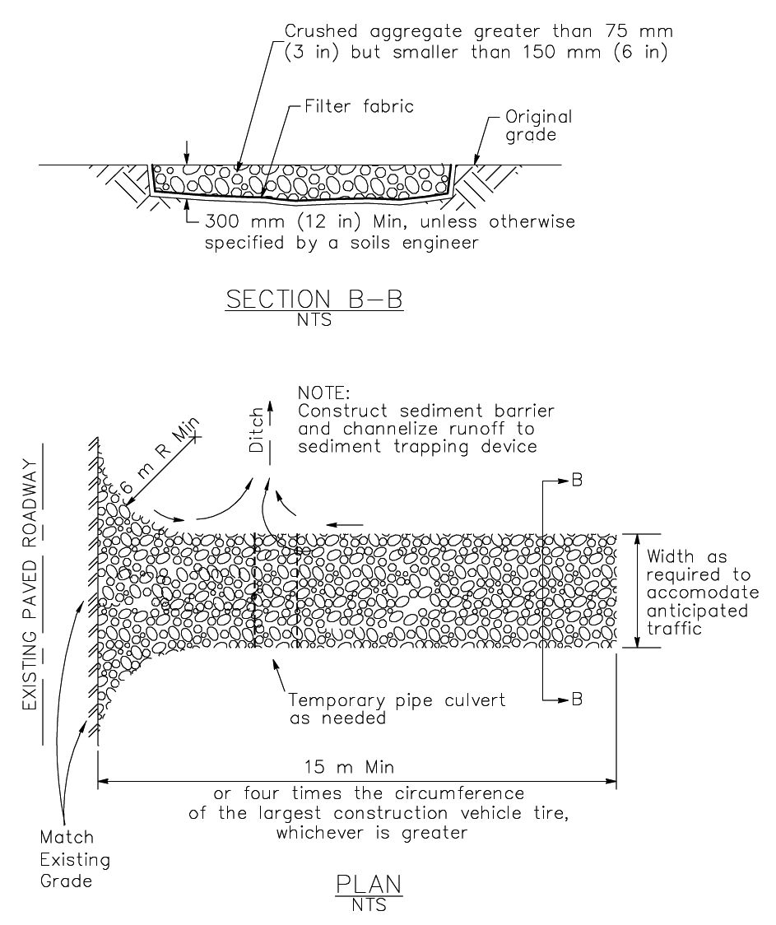
Stabilized Construction Entrance/Exit (Type 1)
Stabilized Contraction Entrance/Exit (Type 1)

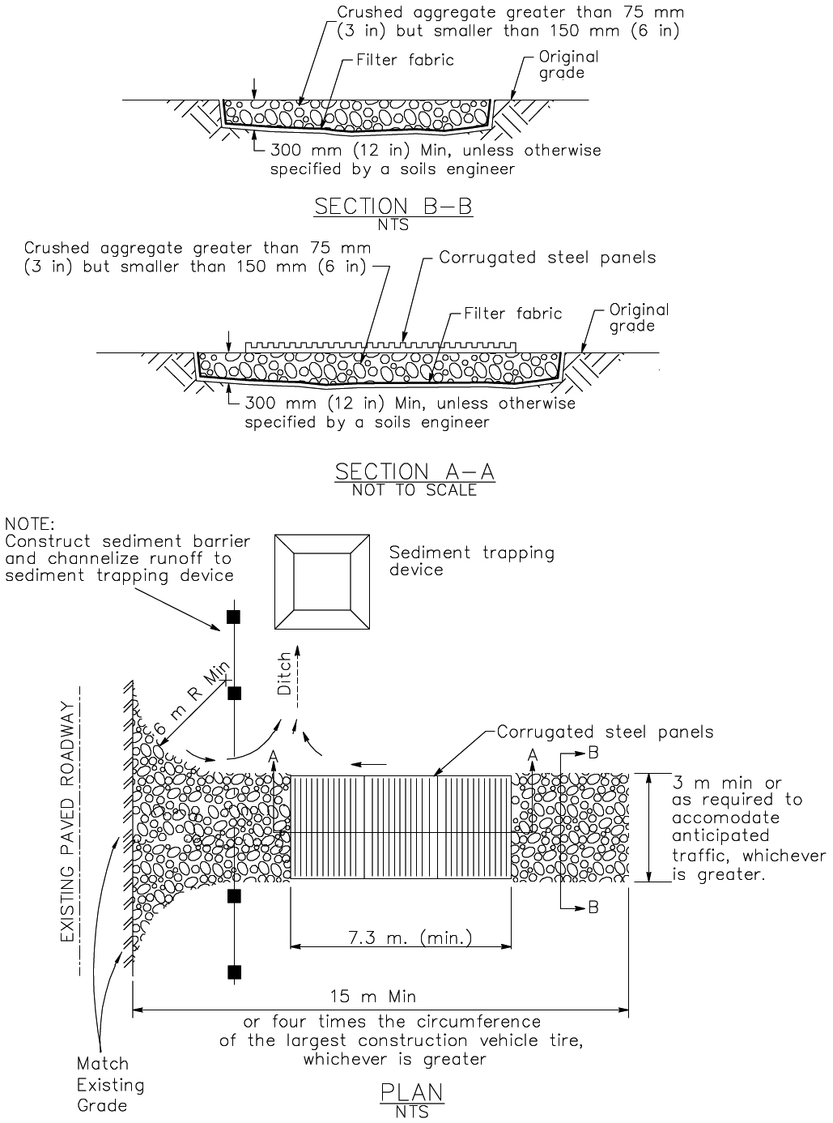
Stabilized Construction Entrance/Exit (Type 2)

