AN OVERVIEW OF BURDENING IN ORACLE GRANTS ACCOUNTING

August 24, 2007 Last Revised: January 7, 2008

At Stanford, burdening refers to the process whereby certain charges are calculated as a percentage of expenditures by the Oracle financial system. These percentages known as rates are either negotiated periodically with the Federal government or set by the Provost’s Office. Vacation accrual, fringe and the tuition grant program are examples of charges that are calculated based on a rate applied to eligible salary expenditures. Indirect cost rates such as the veterinary service center, infrastructure, facilities and administration (F&A) and the Stanford infrastructure program (SIP) are examples of charges calculated as a percentage of eligible salary and non-salary expenditures. The graduate student fellowship stipend surcharge is calculated as a rate on graduate fellowship stipends. Information about these burdens can be found on the ORA web page Stanford Rates. Only expenditures in the 5xxxx expenditure type series are eligible for burdening. The burdens are calculated and posted as charges to PTAs in the Oracle Grants Accounting subsidiary ledger. Auto accounting rules coded into the Oracle financial system determine how the burdens are posted as debits and credits to the general ledger.

Oracle uses burden schedules and burden structures to calculate and apply burdens. Generally a burden schedule contains multipliers (the rates) and the time period to which they apply. The schedule is always linked to a burden structure that defines the expenditure types subject to the multiplier on the schedule and includes information about how the calculations are performed. Every award at Stanford has a burden schedule. See “Assigning the Burden Schedule Name” for information about how burden schedules are defined at the OSR Desk Procedures webpage.

The Burden Schedule (Example at Appendix A)

The burden schedule documents the rates or multipliers and the time period(s) to which the multipliers apply. The rates are organized by burden cost codes. Each burden cost code refers to a specific Stanford rate defined by Oracle as a multiplier. (See Appendix B for a list of burden cost codes and the rates/multipliers to which they pertain). For instance, there is a burden cost code for the Post-Doc fringe rate - BCC_POST_DOC - and there is a burden cost code for the Facilities and Administration indirect charge – BCC_F_AND_A. The burden cost codes also document the expenditure type where the burdening is charged (called the offset expense type by Oracle). For instance in the two examples above, burdening calculated by the multiplier in the burden cost codes BCC_POST_DOC and BCC_F_AND_A are charged to expenditure types 51755 and 56910, respectively.

Multipliers may be changed on an existing burden schedule. (However, Oracle will recost all transactions associated with the changed multiplier. Therefore it is crucial to determine the number of PTAs assigned to the burden schedule to understand the scope of the recosting.)

Burden cost codes are grouped together by versions on the burden schedule. Versions use start and stop dates to define the period of time during which the burden cost codes are active. Each version may have a different (or identical) set of burden cost codes and /or multipliers that are active for that period of time. For Stanford, versions correspond to fiscal years (September – August) as this is the time period we use in rate negotiations. Therefore the multipliers correspond to the rates negotiated for that year. The most recent version in the burden schedule is not end dated.

Stanford has created versions on all burden schedules from fiscal year 1998 onward. Rates prior to FY98 are documented on the OSR Desktop Procedures page. See the schedule “Stanford Institutional Rates to 1975” on the OSR Desk Procedures webpage.

Note: In some cases, we brought awards forward that ended prior to FY98. In these instances, where the awards are subject to ONR rates, you will see some “FY…” schedules with dates prior to FY98.

Oracle burdening uses the expenditure item date (EID) of the transaction to determine which version and therefore, which multiplier/rate of the burden schedule to use. This means that transactions posted within a specific period of time may be subject to different rates because the transaction EIDs fall in different fiscal years. IDC rates are not always affected as they may be fixed for the life of the award (“waived” or “fixed for life”), however salary transactions may be affected as these rates are not fixed and change every year.

Oracle also uses expenditure owning org to control how expenditures are burdened. At
implementation (FY04) Stanford used this feature to prevent expenses (including burdening) converted from the legacy system from being burdened more than once. Converted expenditures have an org of ZZZY and are not burdened as the multipliers associated with the cost codes assigned this org are set to zero. All subsequent expenditures have an expenditure owning org of ZZZZ and are burdened. Burden schedules do not have to be adjusted every time the organization hierarchy changes to a new version because all versions include orgs ZZZZ and ZZZY. Therefore the version hierarchy is defaulted to version “1” on all schedules.

Burden cost codes may be reused within a version as long as the expenditure owning org is different. Cost codes may be reused in different versions and may have different multipliers.

A burden structure is linked to every burden schedule. This structure tells the burden schedule what expenditure types are burdened and how they are burdened. The bridge between the burden schedules and burden structures is the burden cost code. This code associates the multiplier (in the schedule) with the expenditure types (in the structure).

Oracle permits the assignment of more than one structure to a burden schedule whenever a new version is created. Specifically this procedure allows us to assign a different structure when creating a new version. This procedure is used when we need to delete expenditure types from the structures.

For more information about burden schedules, see the documents “Creating a Burden Schedule and Structure in Oracle” and “Burden Schedules and Associated Structures”.

The Burden Structure (See Appendix C)

Each burden schedule is linked to a burden structure. The burden structure details how the cost codes (multipliers) are applied to the expenditure types. Burden structures are organized into indirect cost bases – MTDC, TDC, SAL, SAL with Fringe, ISC and UC plus some very specialized structures for specific sponsored projects. These bases are collections of expenditure types – salary and non-salary - that are burdened in a specific way by government, sponsor and University regulations as implemented by the Office of Cost and Management Analysis, the Dean of Research and the Provost’s Office. See the documents “Assigning the Burden Structure Name” and “Burden Structures” for more information about structures. All structures (and therefore schedules) include vacation accrual, fringe benefits (except TGP) and the veterinary service center charge. All other components appear if the burden schedule meets the criteria for their use. An expenditure type must be entered on the structure to be burdened.

Oracle burden structures are made up of cost bases which document unique collection of expenditure types that are burdened in an identical way. (See Appendix D for a list of the cost bases.) The cost base consists of (1) cost codes which correspond to the multipliers, (2) a precedence indicator expressed as a number which documents the order in which the cost codes (multipliers) are applied and (3) the expenditure types that make up the cost base. Cost codes calculate burdening based on precedence.

Cost codes with a larger number as a precedence (for example 30 verses 20) calculate burdening on the expenditure types (as noted above) and then calculate burdening on the burdening calculated by cost codes with lower numeric precedence. Cost codes with the same numeric precedence do not calculate burdening on each other.

Precedence may be summarized as follows:

- For salary expenditures:

- Vacation accrual calculated on salary (usually precedence “10”).
- TGP calculated on salary and vacation accrual (usually precedence “20”).
- Fringe calculated on salary & vacation accrual (but not TGP) (usually precedence “20”).
- IDC calculated on salary, vacation accrual, TGP and fringe (usually precedence “30”).

- For non-salary expenditures:

- IDC is calculated on the non-salary expenditure.

Note: Infrastructure can be tricky to calculate on salary because not only is the salary excluded from ISC but also the vacation accrual, TGP and fringe on the excluded salary is excluded from TGP.

An expenditure type or cost base may only be used once anywhere on an individual structure. Cost codes may be reused within a structure (for example BCC_F_AND_A) on different cost bases. Expenditure types on existing schedules may not be deleted.

Note: Journals directly charging the offset expense types for vacation accrual, fringe benefits, and the Tuition Grant program are not charged F&A or ISC/UC or SIP because the offset expense types are not on the burden structures. F&A, ISC/UC and SIP must be manually calculated and posted. See the Burdening Adjustment Guidelines.

Because an expenditure type may only be used once, we must include all components of burdening in the cost base. For example, a salary cost base may include the following burdens: vacation accrual, fringe and F&A. On the MTDC burden structure we find the following cost base, “LABOR_RBE_EXEMPT”. These are exempt regular benefits eligible salary expenditure types.

Cost Base: LABOR_RBE_NONEXEMPT
Cost Base Type | Cost Base Description | Start Date | End Date
INDIRECT COST |  | 01-JAN-1990

Cost Codes & Expenditure Types:
Precedence | Cost Code |  | Expenditure Type | Expenditure Type Description
10 | BCC_VAC_NONEXEMPT |  | 51525 | RBE NON EXEMPT
20 | BCC_REGULAR BENEFITS |  | 51528 | RBE NON EXEMPT STRT OVERTIME
20 | BCC_F_AND_A |  | 51560 | RBE NON EXEMPT VAC USED

This cost base – regular benefits eligible nonexempt labor (salary) consists of three expenditure types – 51525, 51528 and 51560. On the MTDC base these expenditure types are subject to the nonexempt vacation accrual rate, the regular benefits rate and the F& A rate. The precedence documents that the nonexempt vacation accrual (precedence 10) is calculated first on the two salary ETs. Then regular benefits (precedence 20) is calculated on the salary and the vacation accrual calculated above. Then the F and A (precedence 30) is calculated on the salary, the vacation accrual calculated above and the regular benefits calculated on the salary and vacation accrual.

How Burden Schedules are applied

All awards must have a burden schedule. The award burden schedule may be overridden at the project or task by assigning a different burden schedule.

- Award Burden Schedule: Any transaction charged to the award regardless of the project or task will be burdened by this schedule.

- Project Burden Schedule Override: Any transaction charged to the project and award regardless of the task will be burdened by this schedule.

- Task Burden Schedule Override: Any transaction charged to this task (and project and award ) will be burdened by this schedule.

Burden schedules may be changed at will. Oracle will not recost transactions when the burden schedule is changed.

How Burden Schedules are organized

See the documents: “Burden Schedules and Associated Structures” and “Assigning a Burden Schedule Name”. Note that all burden schedules starting with “FY…” incorporate OMB Circular A-21 “Fixed for Life”. For more information about “Fixed for Life” see “Selecting the Correct Burden Schedule for Awards Subject to ONR Negotiated Rates”.

How Burden Structures are organized

See the documents: “Burden Structures” and “Assigning a Burden Structure Name”.

How Burdening is posted in Oracle

The cost codes document the expenditure type where the burdening is charged in the Grants Accounting subsidiary ledger. Auto accounting rules define how burdening (debit and credit) is posted to the general ledger. See Appendix B.

Printing the Burden Schedule or Structure
The burden schedule or structure can be printed in Reportmart. See the following reports:

FIN REF 220 Brdn Sched Data Ext
FIN REF 221 Burden Schedule
FIN REF 222 Brdn Struct Data Ext
FIN REF 223 Burden Structure

Maintenance of Burden Schedule and Structures

- Adding new expenditure types to structures
- Creating new schedules
- Creating new schedules with new structures
- Annual updating of schedules for the next fiscal year (adding a new version)
- Adding a new structure to a new version.
- Creating a new burdening program.

Access to Oracle Burden Schedules and Structures

Burden schedules and structures are accessed via the SU GA ORA Compliance Setup responsibility.

More Information about rates and exp types and burdening can be found at the CMA web page: Stanford Rates.
Calculating Burdening – How schedules and structures work together

We have sponsored PTA 1564669-1-PXXAG with an award burden schedule of FY05_RSCH_ON_GOV. There is a transaction totaling $1000.00 with an expenditure item date of March 15, 2005 posted to ET 51525 on the PTA.

- Looking at the award schedule FY05_RSCH_ON_GOV we see the structure attached to the schedule is “MTDC”. We look at the MTDC structure for the burden cost base for our expenditure type. We know that on any one structure an expenditure type may appear only once. The expenditure type appears in the burden cost base LABOR_RBE_NONEXEMPT.

Cost Base: LABOR_RBE_NONEXEMPT
Cost Base Type | Cost Base Description | Start Date | End Date
INDIRECT COST |  | 01-JAN-1990

Cost Codes & Expenditure Types:
Precedence | Cost Code |  | Expenditure Type | Expenditure Type Description
10 | BCC_VAC_NON_EXEMPT |  | 51525 | RBE NON EXEMPT
20 | BCC_REGULAR BENEFITS |  | 51528 | RBE NON EXEMPT STRT OVERTIME
20 | BCC_F_AND_A |  | 51560 | RBE NON EXEMPT VAC USED

- We now know the collection of burden cost codes associated with the expenditure type. They are: BCC_VAC_NON_EXEMPT, BCC_REGULAR_BENEFITS and BCC_F_ AND_A.
- We go to the burden schedule and using the EID of the transaction we identify which version we will use. Here we select the FY05 version as the EID falls within the period 01-SEP-04 through 31-AUG-2005, the start/stop date of the FY05 version.
- Once we have the version we identify the rates (multipliers) associated with the burden cost codes in the burden cost base. We are ready to perform the calculation.

Burden Cost Base Rate

BCC_VAC_NON_EXEMPT 0.0740
BCC_REGULAR_BENEFITS 0.3050
BCC_F_ AND_A 0.5700

- The Calculation

To perform the calculation and charge the appropriate expenditure type with the result we need to look at the precedence associated with each cost code and the expenditure type offset associated with each cost code.

a. BCC_VAC_NON_EXEMPT (precedence is 10 so it is first)

$1,000.00 * 0.0740 = $74.00

This cost code posts the result ($74.00) to ET 51561.

b. BCC_REGULAR_BENEFITS (precedence is 20 so it is second)

($1000.00 + $74.00) * 0.3050 = $327.57
This cost code posts the result ($327.57) to ET 51750.

c. BCC_F_ AND_A (precedence is 30 so it is third)

($1000.00 + $74.00 + $327.57) * 0.5700 = $798.89

This cost code posts the result ($798.89) to ET 56910.

See Notes A and B for an examples of burden reconciliations.

Oracle burdening creates a “combined multiplier” that represents the net affect of the above calculations and therefore avoids this “stepped” calculation. The combined multiplier xcan be seen on the RM3 FIN EXP 105 report.

Tools to Assist the Reconciliation of Burdening (Actuals)

- RM3 FIN EXP 105 Burdening Recon Report
This report recalculates burdening using the same burden schedules and structures as Oracle with detail about the burden calculation.

- RM3 FIN OSR 240 Claim and Recon Report (tab “Burden Variance Report By Month”)
This report sums month by month all burdening as posted by Oracle and as calculated by the 105 report. The difference (if any) is displayed as a variance.

- Oracle Expenditure Inquiry (Grants Accounting)
This Oracle query facility allows the user to download transactions and review burdening details as they occurred.

- View (award) screen in Oracle (Burden Schedule setup)
This screen allows users to test the burden schedule on a specific PTA.

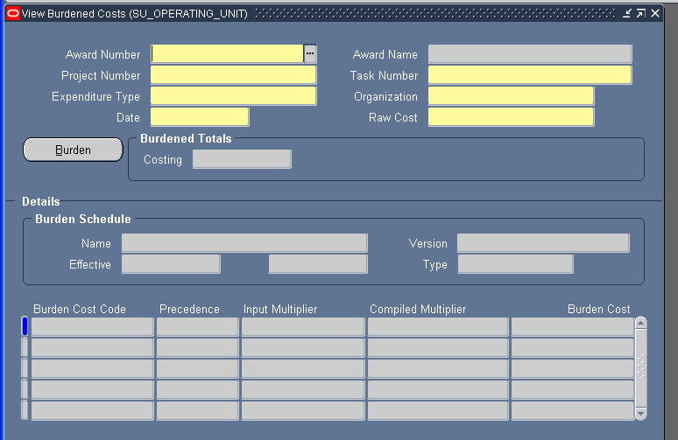

- Burden Expenditure Type Mapping Schedule
This spreadsheet documents how expenditure types are burdened.

Oracle Commitments and Burdening

Starting in FY08 (9/01/07) Stanford implemented Oracle encumbrances (commitments). Commitments are burdened using the same burden schedules and structures as actual expenses. Generally burden commitments are calculated on salary, financial aid and purchasing commitments and are adjusted as these commitments change.

Transaction Source | Description | Comments
Purchasing/ A/P | As the approved requisition commitment is posted and then is replaced by the PO commitment which is then liquidated/reduced by the invoice, at each step Oracle recalculates the burdening commitment on the net amount of the requisition/PO using the current burden schedule rates. | - The burden commitment on a requisition or a PO will not be updated until activity takes place in Purchasing or Accounts Payable (AP). Typically this is the invoice matching process that results in a charge to the PTA and the liquidation/reduction of the PO commitment. This means the burden commitment on a PO may be incorrect if we:  - Change the burden schedule on the PTA and there is no activity in Purchasing/AP to trigger the burden commitment update.  - Update the burden schedule rates for the next year and there is no activity in Purchasing/AP to trigger the burden commitment update.  - Compensating facts are:  - This issue only affects PTAs that are subject to indirect costs (F&A or infrastructure (ISC).  - Many awards subject to indirect costs have F&A rates that are fixed for the life of the award so a change in the schedule version from one year to the next may not change the burden rate and burden commitment.  - Departments may request Purchasing to suppress the purchase order if the remaining PO commitments are not expected to be paid.

Transaction Source | Description | Comments
Salary | Oracle calculates outstanding burden commitments on salary using the current burden schedule rates except when we change the burden schedule on the PTA. Stanford has implemented a workaround for burden schedule changes that forces the burden commitment on salary to recalculate using the new burden schedule rates. | Outstanding burdening commitments on salary are calculated using the current burden schedule rates. Outstanding burden commitments are updated whenever we adjust the labor schedule, update the burden schedule rates for the next year or change a burden rate that is incorrect. Burden commitments on salary are not updated whenever we change a burden schedule. Stanford implemented a customization in Oracle to force burdening commitments on salary to recalculate using the new burden schedule rates.  Salary commitments are liquidated at the burden schedule rate in effect at the time the original burden commitment was incurred. This ensures the liquidation of salary commitments properly clears the associated burdening commitments.
Student Financial Commitments | Oracle calculates the burden commitments on student financial aid using the current burden schedules rate at the time the student aid commitment was incurred. | Student financial commitments are reversed and reposted each month. The reversal is burdened at the burden schedule rate in effect at the time the original burden commitment was incurred. The new outstanding student aid commitments are burdened at the current burden schedule’s rate.  Outstanding burden commitments may be incorrect when we update the burden schedule rates for the next year, change a burden rate that is incorrect or change a burden schedule on the PTA until the next month when the student aid commitment is reversed and reposted.

Transaction Source | Description | Comments
Infrastructure and Alternate PTAs | For those PTAs that are subject to the infrastructure (ISC) charge and have an alternate PTA to accept the ISC, the ISC burden commitment will be reported in the alternate PTA as well. | This is a reporting (EDW) solution only. The infrastructure burden commitment will appear in the alternate PTA in reporting only. The infrastructure burden commitment is not moved to the alternate PTA in Oracle. For more information about Stanford’s infrastructure policy see the infrastructure implementation guidelines.

Tools to Assist the Reconciliation of Burdening Commitments

            - Core Oracle Burden Commitment Report
This is a custom Oracle report that documents details about the burden commitment calculations by PTA for the prior month or the current period.

            - Award Status Inquiry
Standard Oracle functionality that can be used to download commitment transactions.

- Burden Expenditure Type Mapping Schedule
This spreadsheet documents how expenditure types are burdened.

THE INFRASTRUCTURE ALT PTA CUSTOMIZATIONS IN ORACLE GRANTS ACCOUNTING

Background
Several customizations have been created to move infrastructure (including the utility charge) on sponsored and non-sponsored PTAs to an alternate PTA in legacy (SUFIN) and Oracle. The ALT PTA customization implements that part of ISC policy that allows a PTA other than the PTA that generated the infrastructure charge (ISC) /utility charge (UC) to pay for the ISC/UC. These customizations move the charge from the PTA originating the charge to another PTA coded in designated flex fields on the task (sponsored awards) or references on the award (non-sponsored awards). There are two ISC policies – the 6% policy which includes the utility charge and the revised 8% policy effective FY06.

ALT PTA Customization (Implemented 8/14/04)

The ALT ISC customization began moving ISC charges created on or after 12-AUG-2004. (ISC charges incurred prior to that date were moved manually by journal.) Starting Oct 2004, Stanford changed the ISC expenditure types to 58xxx. The ALT PTA customization was changed to include these new expenditure types as well. We did not go back and reclassify ISC charges from the old ETs to the new ETs.

Old Exp Type | Description | New Exp Type | Recovery PTA | Recovery GL/ET
56920 | INFRASTRUCTURE CHARGE | 58910 | 1000752-1-AAPAF | 58910
56930 | UTILTY CHARGE | 58920 | 1000753-1-AAPAF | 58920
56940 | ALT INFRASTRUCTURE CHARGE | 58930 | 1000754-1-AAPAF | 58930
56950 | ALT UTILITY CHARGE | 58940 | 1000755-1-AAPAF | 58940

This customization moved only system-generated ISC (6%) and UC (0.5%) burden charges based on the existence of an ALT PTA coded in flex field on the task. A customized program was run periodically to identify these charges and create a journal to transfer the charges to the ALT PTA and the correct offset PTAs. This journal was manually posted as a feeder journal referenced as “ALTIS”. The line description posted to the ALT PTA included the transaction ID and the PTA where the charge originated.

At this time ALT PTA were only associated with sponsored projects.

ALT PTA Customizations as of FY06 (The revised ISC policy implemented 9/01/05)

Effective 9/01/05 (fiscal year 2006), the ISC policy was revised to charge 8% against a larger population of expenditure types. All sponsored and non-sponsored PTAs are subject to the new policy. However, sponsored projects in existence prior to the effective date of the revised policy continued under the prior 6% policy. We created two new expenditure types to support this program (58915 and 58935). The utility charge (0.5%) was dropped.

New Exp Type | Description | Recovery PTA | Recovery GL/ET
58915 | INTERDEPT ISC CHRG ON EXPENDITURES | 1095050-1-AAPAH
58935 | INTERDEPT ALT ISC CHG ON EXPENDITURES | 1095050-1-AAPAH

- The existing sponsored ALT PTA customization was revised to include the new expenditure types. No other changes were required.

- A new non-sponsored ALT PTA customization was created that moved the ISC charge from the originating PTA to the ALT PTA based on references on the non-sponsored award (not the task.) This customization is run by the Controller’s Office. The customization moves the charge form the origination PTA to the ALT PTA systematically without the need for a journal.

ALT PTA Customizations as of FY08 (Implemented 10/15/07)

- A new sponsored award customization was created to move the ISC/UC to an alternate PTA without the need for a journal. This customization is run by the Controller’s Office. The prior sponsored customization implemented in 8/04 was discontinued.
Oracle Burdening Limitations

EIDs and Earliest Schedule Version

- Currently, Oracle will not allow a transaction to process with an EID date prior to the start date of the earliest version on the burden schedule (currently 9/1/1997). When we have to transfer such transactions in ijournals, we need to use an EID date of 9/1/97, document the actual EID and adjust the burdening to reflect the correct fiscal year. A customization was implemented to prevent the use of an EID date prior to 9/1/1997.

For the CIRM burden schedules, which start in FY08, we created a version with zero multipliers for the period FY98-FY06. We then created an FY07 version for any potential pre-award expenditures.

ORG Hierarchy

- Burden schedules use the org hierarchy version 1. Expenditures with an expenditure owning org of ZZZZ are burdened. Expenditures with org code ZZZY are burdened with a zero rate. Expenditure owning orgs other than these two may not process if the expenditure owning org is not on version 1. ( We are well beyond version 1 at this time.) ZZZZ and ZZZY are on all org hierarchy versions.

Expenditure Types and Burden Structures

- Expenditure types cannot be removed from a burden structure. Expenditure types may not be used more than once within a burden structure.

There is a workaround for deleting an expenditure type. This can be done when we add a new version. A new structure can be created omitting the expenditure type. This structure is then attached to the new version. It is effective from the start date of the version onward.

Burden Cost Bases and Cost Codes

- Burden cost bases/ cost codes cannot be removed are changed. Again the workaround would be a new structure. Burden cost codes may be reused in a version only if they have a different owning org.

Changing a Multiplier

- Changing a multiplier on a compiled version of a burden schedule and recompiling the version will cause Oracle to recost all expenditures subject to that multiplier on awards with the burden schedule. It is crucial to determine the number of PTAs assigned to the burden schedule to understand the scope of the recosting.

Adjustments Posted Directly to the Burden Expenditure Types

- Adjustments posted directly to burden expenditure types are nor burdened by Oracle. While this is not an issue for the IDC burden expenditure types, it is an issue for the salary burden expenditure types such as vacation accrual, fringe and TGP. These expenditure types are burdened by other burdens. For example an adjustment made to vacation accrual will not be burdened by fringe, TGP or IDC/ISC. These burdens have to be calculated a posted manually. Any burdens lower in precedence to the burden under adjustment will not burdened the adjustment.

Expenditure Owning ORG

- To convert legacy expenditures to the new Oracle financial system, Stanford used the expenditure owning org (EOO) to control burdening. Legacy expenditures were converted with an EOO of ZZZY which was not burdened. All subsequent expenditures defaulted to an EOO of ZZZZ. However, this scheme relied on all sources of transactions restricted to EOO of ZZZZ. Some sources (such as AP) were not changed to an EOO of ZZZZ from ZZZY. Some modules allow the user to select/change the EOO (such as salary and AP). This resulted in transactions that were not burdened because they had EOOs of ZZZZ.

Commitments and Burdening

- No process exists to correct burdening commitments. They can be suppressed by the department.

Note A: Sample Burden Reconciliation of a FY08_RSCH_ON_NON_GOV Schedule based on the RM3 179 Report

Sample reconciliation is based on the RM3 179 report. This example reconciles salary related burdens, IDC and VSC indirect charges.

Notes
For salary expenditures:

- Vacation accrual is calculated on salary.
- TGP is calculated on salary and vacation accrual
- Fringe is calculated on salary and vacation accrual (but not TGP)
- IDC is calculated on salary, vacation accrual, TGP and fringe.

For non-salary expenditures, IDC is calculated on the non-salary expenditure.
Refer to the Burden Expenditure Type Mapping Schedule for information about how exp types are treated by burdening. (The base here is MTDC.)

Expenditures, especially salary with EIDs in different fiscal years can make the reconciliation more complex. Infrastructure can be difficult to reconcile on salary as not only is the salary excluded from ISC but also the vacation accrual, TGP and fringe on the excluded salary is excluded from TGP.

Note B: Sample Burden Reconciliation of a CIRM (California Institute for Regenerative Medicine) Research Award based on the RM3 179 Report

The CIRM IDC ETs 56912, 56914, and ET 56918 only appear on California Institute for Regenerative Medicine (CIRM) research awards. Category A (56912) and Category B (56914) rates are applied to the MTDC base independently of each other. The Admin rate (56918) is applied to the MTDC base and the Category A and Category B burdens.

Sample reconciliation is based on the RM3 179 report. This example reconciles IDC only.

Notes
For salary expenditures:

- Vacation accrual is calculated on salary.
- TGP is calculated on salary and vacation accrual
- Fringe is calculated on salary and vacation accrual (but not TGP)
- IDC is calculated on salary, vacation accrual, TGP and fringe.

For non-salary expenditures, IDC is calculated on the non-salary expenditure.
Refer to the Burden Expenditure Type Mapping Schedule for information about how exp types are treated by burdening. (The base here is MTDC.)
Expenditures, especially salary with EIDs in different fiscal years can make the reconciliation more complex.

Note B: Sample Burden Reconciliation of a CIRM Research Award - continued -

CIRM burden schedules are unique as their rates (CAT A, CAT B and Administrative) are effective for the period 7/1/YY – 6/30/YY of each year. All fringe rates are effective for the fiscal year. So for each fiscal year there will be a FY0YA and a FY0YB version.

For example:

Version | Effective Time Period | Comment
FY07A | 9/01/06 -8/31/07 | Fringe rates effective FOR FY07. In addition, this schedule addresses any potential pre-award expenses.
FY07B | 9/01/07 – 6/30/08 | New fringe rates. IDC rates do not change.
FY08A | 7/1/08 – 8/31/08 | New IDC rates. Fringe rates do not change.
FY08B | 9/1/08 – 6/30/09 | New fringe rates. IDC rates do not change.

APPENDIX A

BURDEN SCHEDULE EXAMPLE (FY05_RSCH_ON_GOV) with two versions (FY05 and FY04)
Source: RM3 FIN REF 221

Burden Schedule: FY05_RSCH_ON_GOV
Start Date | End Date | Structure | Type | Hierarchy | Ver | Start Org | Start Org Name
01-Jan-1990 |  | MTDC | Provisional | Organizational Hierarchy | 1 | AA00 | University General

FY05 Version
Start Date | End Date | Compiled | Compile Date | ORG | Burden Cost Code | Multiplier
01-Sep-04 |  | X | 20-AUG-2004 | AA00 | BCC_CONTINGENT_TEMP | 0.0890
01-Sep-04 |  | X | 20-AUG-2004 | AA00 | BCC_F_AND_A | 0.5700
01-Sep-04 |  | X | 20-AUG-2004 | AA00 | BCC_GRADUATE_RA_TA | 0.0340
01-Sep-04 |  | X | 20-AUG-2004 | AA00 | BCC_POST_DOC | 01910
01-Sep-04 |  | X | 20-AUG-2004 | AA00 | BCC_REGULAR_BENEFITS | 0.3050
01-Sep-04 |  | X | 20-AUG-2004 | AA00 | BCC_STUDENT_ZERO | 0.0000
01-Sep-04 |  | X | 20-AUG-2004 | AA00 | BCC_VAC_BARGAINING_UNIT | 0.0740
01-Sep-04 |  | X | 20-AUG-2004 | AA00 | BCC_VAC_EXEMPT | 0.0880
01-Sep-04 |  | X | 20-AUG-2004 | AA00 | BCC_VAC_NON_EXEMPT | 0.0740
01-Sep-04 |  | X | 20-AUG-2004 | AA00 | BCC_VSC | 0.7650
01-Sep-04 |  | X | 20-AUG-2004 | ZZZY | BCC_CONTINGENT_TEMP | 0.0000
01-Sep-04 |  | X | 20-AUG-2004 | ZZZY | BCC_F_AND_A | 0.0000
01-Sep-04 |  | X | 20-AUG-2004 | ZZZY | BCC_GRADUATE_RA_TA | 0.0000
01-Sep-04 |  | X | 20-AUG-2004 | ZZZY | BCC_POST_DOC | 0.0000
01-Sep-04 |  | X | 20-AUG-2004 | ZZZY | BCC_REGULAR_BENEFITS | 0.0000
01-Sep-04 |  | X | 20-AUG-2004 | ZZZY | BCC_STUDENT_ZERO | 0.0000
01-Sep-04 |  | X | 20-AUG-2004 | ZZZY | BCC_VAC_BARGAINING_UNIT | 0.0000
01-Sep-04 |  | X | 20-AUG-2004 | ZZZY | BCC_VAC_EXEMPT | 0.0000
01-Sep-04 |  | X | 20-AUG-2004 | ZZZY | BCC_VAC_NON_EXEMPT | 0.0000
01-Sep-04 |  | X | 20-AUG-2004 | ZZZY | BCC_VSC | 0.0000

FY04 Version
Start Date | End Date | Compiled | Compile Date | ORG | Burden Cost Code | Multiplier
01-Sep-03 | 31-Aug-2004 | X | 20-AUG-2004 | AA00 | BCC_CONTINGENT_TEMP | 0.0910
01-Sep-03 | 31-Aug-2004 | X | 20-AUG-2004 | AA00 | BCC_F_AND_A | 0.6000
01-Sep-03 | 31-Aug-2004 | X | 20-AUG-2004 | AA00 | BCC_GRADUATE_RA_TA | 0.0350
01-Sep-03 | 31-Aug-2004 | X | 20-AUG-2004 | AA00 | BCC_POST_DOC | 01870
01-Sep-03 | 31-Aug-2004 | X | 20-AUG-2004 | AA00 | BCC_REGULAR_BENEFITS | 0.2900
01-Sep-03 | 31-Aug-2004 | X | 20-AUG-2004 | AA00 | BCC_STUDENT_ZERO | 0.0000
01-Sep-03 | 31-Aug-2004 | X | 20-AUG-2004 | AA00 | BCC_VAC_BARGAINING_UNIT | 0.0745
01-Sep-03 | 31-Aug-2004 | X | 20-AUG-2004 | AA00 | BCC_VAC_EXEMPT | 0.0865
01-Sep-03 | 31-Aug-2004 | X | 20-AUG-2004 | AA00 | BCC_VAC_NON_EXEMPT | 0.0745
01-Sep-03 | 31-Aug-2004 | X | 20-AUG-2004 | AA00 | BCC_VSC | 0.7750
01-Sep-03 | 31-Aug-2004 | X | 20-AUG-2004 | ZZZY | BCC_CONTINGENT_TEMP | 0.0000
01-Sep-03 | 31-Aug-2004 | X | 20-AUG-2004 | ZZZY | BCC_F_AND_A | 0.0000
01-Sep-03 | 31-Aug-2004 | X | 20-AUG-2004 | ZZZY | BCC_GRADUATE_RA_TA | 0.0000
01-Sep-03 | 31-Aug-2004 | X | 20-AUG-2004 | ZZZY | BCC_POST_DOC | 0.0000
01-Sep-03 | 31-Aug-2004 | X | 20-AUG-2004 | ZZZY | BCC_REGULAR_BENEFITS | 0.0000
01-Sep-03 | 31-Aug-2004 | X | 20-AUG-2004 | ZZZY | BCC_STUDENT_ZERO | 0.0000
01-Sep-03 | 31-Aug-2004 | X | 20-AUG-2004 | ZZZY | BCC_VAC_BARGAINING_UNIT | 0.0000
01-Sep-03 | 31-Aug-2004 | X | 20-AUG-2004 | ZZZY | BCC_VAC_EXEMPT | 0.0000
01-Sep-03 | 31-Aug-2004 | X | 20-AUG-2004 | ZZZY | BCC_VAC_NON_EXEMPT | 0.0000
01-Sep-03 | 31-Aug-2004 | X | 20-AUG-2004 | ZZZY | BCC_VSC | 0.0000

Notes: The latest burden schedule version is never end dated until the next version (Next fiscal year’s set of rates) is added. For information about creating a burden schedule see “Creating a Burden Schedule and Structure in Oracle”.

APPENDIX B

BURDENS AND ASSOCIATED COST CODES AND BURDEN OFFSET EXPENDITURE TYPES

Category | Burdens | Burden Cost Code | Source Authority | Offset Exp Type | GL Auto Accounting | Effective From Date
Fringe | Vacation Accrual Exempt | BCC_VAC_EXEMPT | ONR Negotiated | 51556 | 51552/23300 | 1-Jan-90
Fringe | Vacation Accrual – Non-Exempt | BCC_VAC_NON_EXEMPT | ONR Negotiated | 51561 | 51552/23300 | 1-Jan-90
Fringe | Vacation Accrual – Bargaining Unit | BCC_VAC_BARGAINING_UNIT | ONR Negotiated | 51566 | 51552/23300 | 1-Jan-90
Fringe | Fringe Regular Benefits Eligible | BCC_REGULAR_BENEFITS | ONR Negotiated | 51750 | 51701/51701 | 1-Jan-90
Fringe | Fringe – Post Doc | BCC_POST_DOC | ONR Negotiated | 51755 | 51701/51701 | 1-Jan-90
Fringe | Fringe – Contingent | BCC_CONTINGENT_TEMP | ONR Negotiated | 51760 | 51701/51701 | 1-Jan-90
Fringe | Fringe – Grad RA/TA | BCC_GRADUATE_RA_TA | ONR Negotiated | 51775 | 51701/51701 | 1-Jan-90
Fringe | Tuition Grant Program | BCC_TGP | Budget Office | 51770 | 51701/51701 | 1-Jan-90
Other | Grad Student Stipend Surcharge | BCC_GRAD_STIPEND_SUBSIDY | Budget Office | 57640 | 57601/57601 | 1-Jan-90
Indirect | F and A | BCC_F_AND_A |  | 56910 | 56900/56900 | 1-Jan-90
Indirect | CIRM Facility Category A | BCC_FAC_CAT_A | CA State Negotiated | 56912 | 56900/56900 | 01-Sep-06
Indirect | CIRM Facility Category B | BCC_FAC_CAT_B | CA State Negotiated | 56914 | 56900/56900 | 01-Sep-06
Indirect | CIRM Operations and Maintenance | BCC_O_AND_M | CA State Negotiated | 56916 | 56900/56900 | 01-Sep-06
Indirect | CIRM Administrative Expense | BCC_ADMIN | CA State Negotiated | 56918 | 56900/56900 | 01-Sep-06
Indirect | Infrastructure (policy prior to 9/1/05) | BCC_ISC | Budget Office | 58910 | 58901/58901 | 1-Jan-90
Indirect | Infrastructure (policy start 9/1/05) | BCC_ISC_FY06 | Budget Office | 58915 | 58901/48901 | 1-Jan-90
Indirect | Utility Charge | BCC_UTILITY | Budget Office | 58920 | 58901/58901 | 1-Jan-90
Indirect | Stanford Infrastructure Program | BCC_SIP | Budget Office | 58590 | 58501/58501 | 1-Jan-90
Indirect | Veterinary Service Center | BCC_VSC | ONR Negotiated | 56920 | 56900/56900 | 1-Jan-90

Not Used

Fringe | Fringe - Student | BCC_STUDENT_ZERO | ONR Negotiated | 51765 | N/A | 1-Jan-90
Indirect | Not Used | BCC_ISC_ALTERNATE | Budget Office | 58930 | N/A | 1-Jan-90
Indirect | Not Used | BCC_ISC_ALTERNATE_FY06 | Budget Office | 58935 | N/A | 1-Jan-90
Indirect | Not Used | BCC_UTILITY_ALTERNATE | Budget Office | 58940 | N/A | 1-Jan-90

Note: The infrastructure charge (policy prior to 9/01/05) was moved to the current expenditure types for the following ETs in 10/04:
56930 Infrastructure Charge
56940 Utility Charge
56940 Alt Infrastructure Charge
56950 Alt Utility Charge

These charges were not moved to the current expenditure types.
APPENDIX C
MTDC BURDEN STRUCTURE EXAMPLE (Partial Report)
Source: RM3 FIN REF 223 Burden Structure

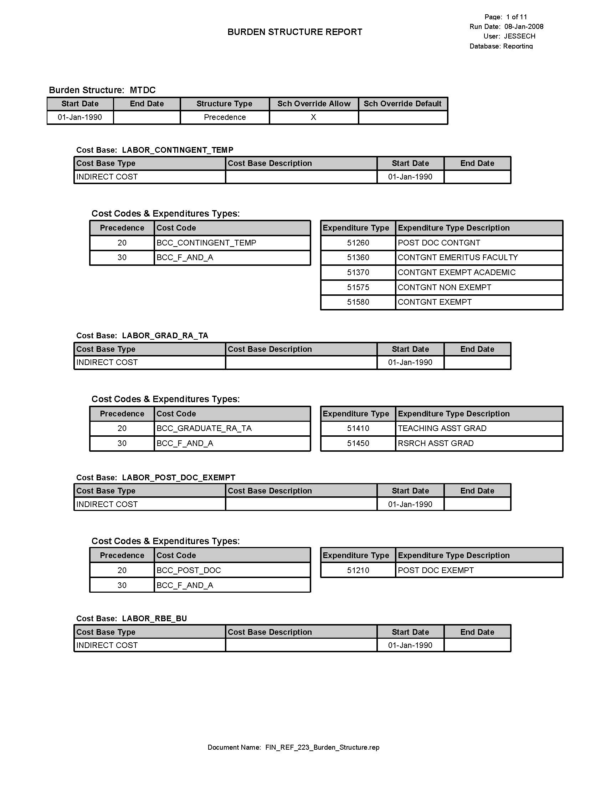
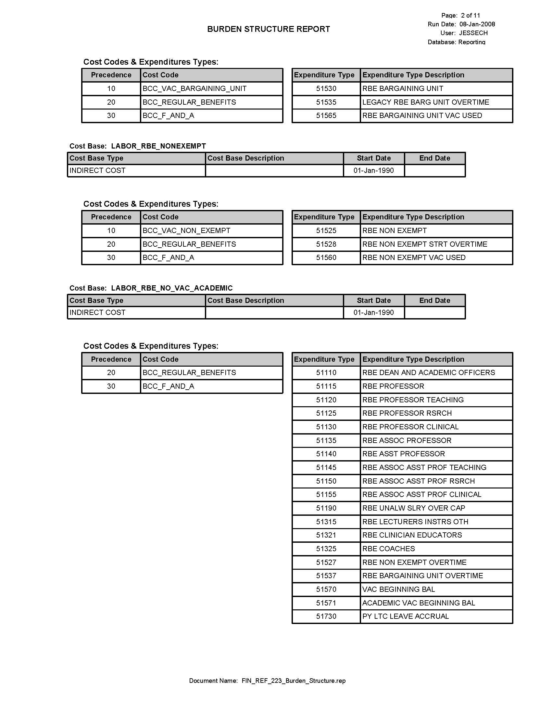
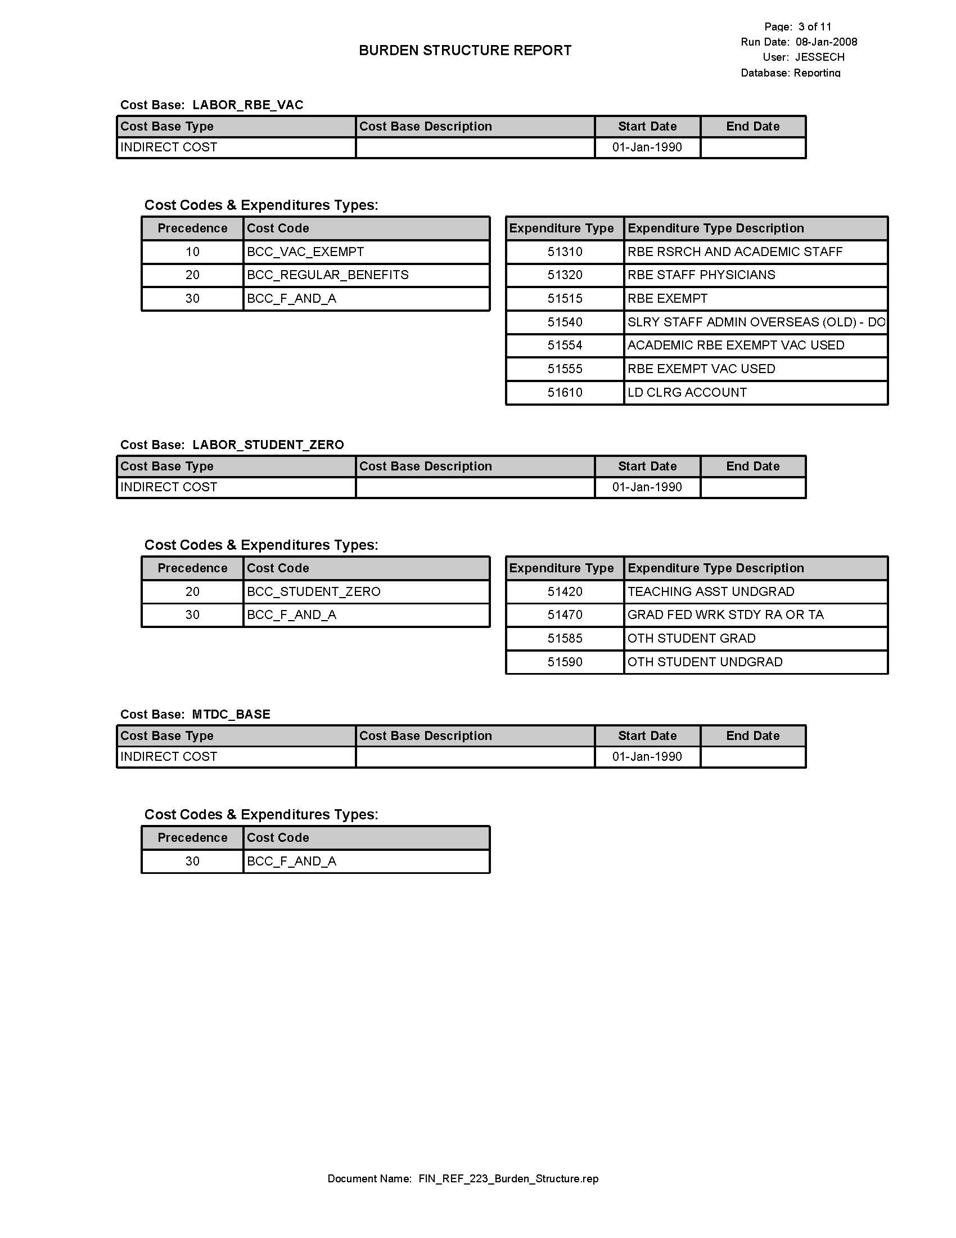
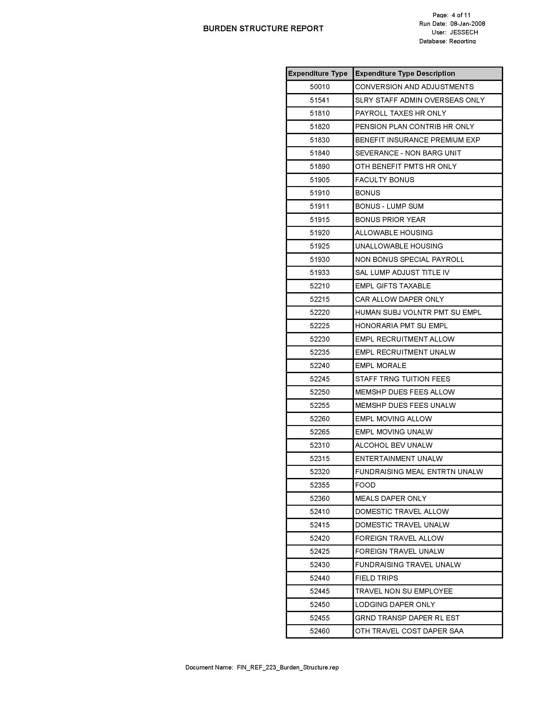

APPENDIX D

COST BASES

The cost bases bring together expenditure types that are burdened in exactly the same way.

Cost Base | Description | Report Order | Cost Base Type | Effective Dates: From
LABOR_POST_DOC_NON_EXEMPT | ETs subject to the Post Doc fringe rate. | 10 | Burden Cost | 1-Jan-90
LABOR_GRAD_RA_TA | ETs subject to the Graduate Student TA/RA Fringe rate. | 20 | Burden Cost | 1-Jan-90
LABOR_RBE_NO_VAC_ACADEMIC | ETs that are subject to the regular benefits fringe rate and are not subject to vacation accrual. | 30 | Burden Cost | 1-Jan-90
LABOR_RBE_NONEXEMPT | Non-exempt ETs subject to the regular benefits rate and the non-exempt vacation accrual rate. | 40 | Burden Cost | 1-Jan-90
LABOR_RBE_VAC | ETs subject to the regular benefits rate and the exempt vacation accrual rate. | 50 | Burden Cost | 1-Jan-90
LABOR_RBE_NO_VAC_ISC | ETs subject to the regular benefits rate are not subject to vacation accrual and are subject to ISC. | 60 | Burden Cost | 1-Jan-90
LABOR_RBE_VAC_NO_ISC | ETs that are regular benefits eligible are subject to vacation accrual and are not subject to ISC. | 70 | Burden Cost | 1-Jan-90
LABOR_WAIVED_ISC_CONTINGENT | Ets subject to the contingent fringe rate but not ISC. | 80 | Burden Cost | 1-Jan-90
LABOR_CONTINGENT_TEMP | Ets subject to the contingent fringe rate. | 90 | Burden Cost | 1-Jan-90
LABOR_RBE_BU | ETs subject to the bargaining unit vacation accrual rate. | 100 | Burden Cost | 1-Jan-90
LABOR_POST_DOC_EXEMPT | ETs subject to the post doc fringe rate. | 110 | Burden Cost | 1-Jan-90
LABOR_STUDENT_ZERO | Student ETs not subject to a fringe rate. | 120 | Burden Cost | 1-Jan-90
MTDC_BASE | ETs subject to the MTDC base. | 130 | Burden Cost | 1-Jan-90
TOTAL_BASE | ETs subject to the TDC base. | 140 | Burden Cost | 1-Jan-90
GRAD_STIPEND_SUBSIDY | ETs subject to the Graduate Student Stipend Surcharge | 150 | Burden Cost | 1-Jan-90
ISC_BASE | ET subject to infrastructure (and utility charge). | 160 | Burden Cost | 1-Jan-90
SIP_BASE | ETs subject to the Stanford Infrastructure Program (limited to Capital Accounting) | 170 | Burden Cost | 1-Jan-90
VSC | ET subject to the Veterinary service Center rate. | 180 | Burden Cost | 1-Jan-90

All rates are negotiated by fiscal year. Fringe rates are negotiated annually for one fiscal year. F&A rates are negotiated every two years and result in a separate set of rates for each fiscal year.
The Dean of Research (and designates) can also waive the federal negotiated rate to a lesser rate or zero.
CIRM burden schedule versions are effective for a different period of time : 7/1 – 6/30
If a converted expenditure is later moved, the transfer defaults to a ZZZZ expenditure owning org so that burdening is properly adjusted.
There is a separate ISC customization that operates in the general ledger only. The implementation of Oracle encumbrances also has a separate process for handling ALT PTAs.

