
Office of Sponsored Research
Stanford University

ORACLE FINANCIALS

GUIDE TO SETTING UP
PROJECTS, TASKS
AND AWARDS

Table of Contents
Table of Contents 1
Required documents for PTA setup 2
Getting Started 3
Project Set up 6
Project, Template Summary 7
Project Quick Entry 7
Project Template 8
Project Descriptive Flex Field (DFF) 9
Project Options 9
Task Setup 9
Find Tasks 9
Tasks 10
Descriptive Flex Field 10
Task Options 11
Task Detail 12
Task Transaction Controls 13
Key Members 14
Award Setup 16
Award Management Folder 17
Award Quick Entry 17
Award Descriptive Flex Field (DFF) 20
Award Management Window 21
Installments 21
Project Funding 22
Terms and Conditions 24
Budgetary Control 24
Customer Address 25
Contacts 26
Personnel 26
Compliances 27
Reports 27
References 28
Budgeting Awards 29
Task Budgets Window 30
Budget Lines Window 31
NOTIFY DEPARTMENT OF THE PROJECT TEMPLATE USED TO SET UP ORACLE PROJECT …..…………………..……32

Required documents for PTA setup
The following are required before any project, task or award is set up:
SU-42 (Joint Personnel Agreements do not need an SU-42)
ePTA form received after departmental approval (new awards only)
Grant/contract documents
Budget
Waivers (PI or IDC) if applicable
Early account request form (fully signed/approved)
Cost sharing form
Please use all CAPS as you are entering information in the system.

Getting Started

1. Go to the following URL http://fingate.stanford.edu and click on Staff.

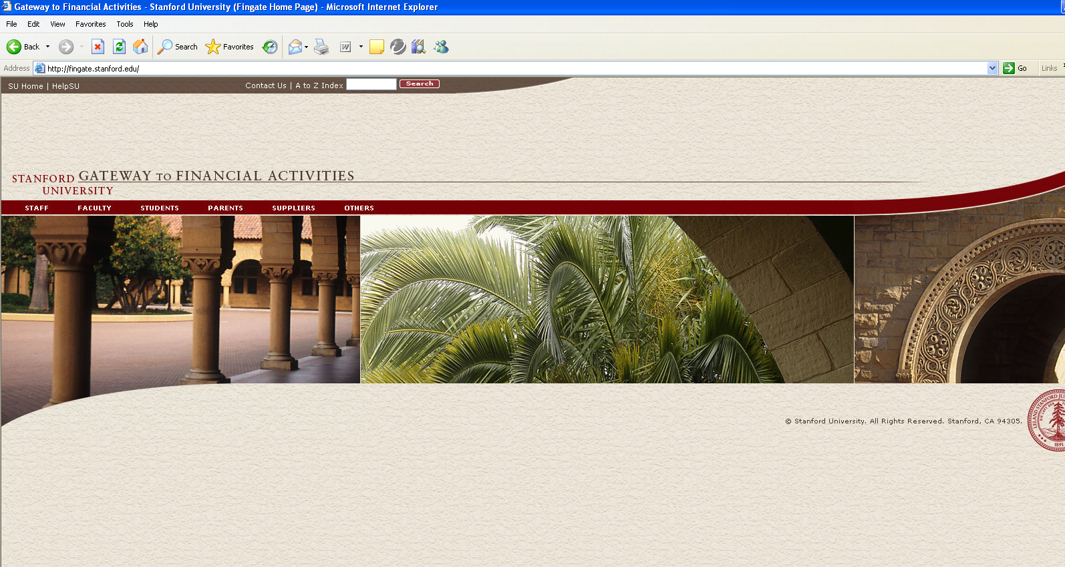
Web Page

2. To open up Oracle click on Go.

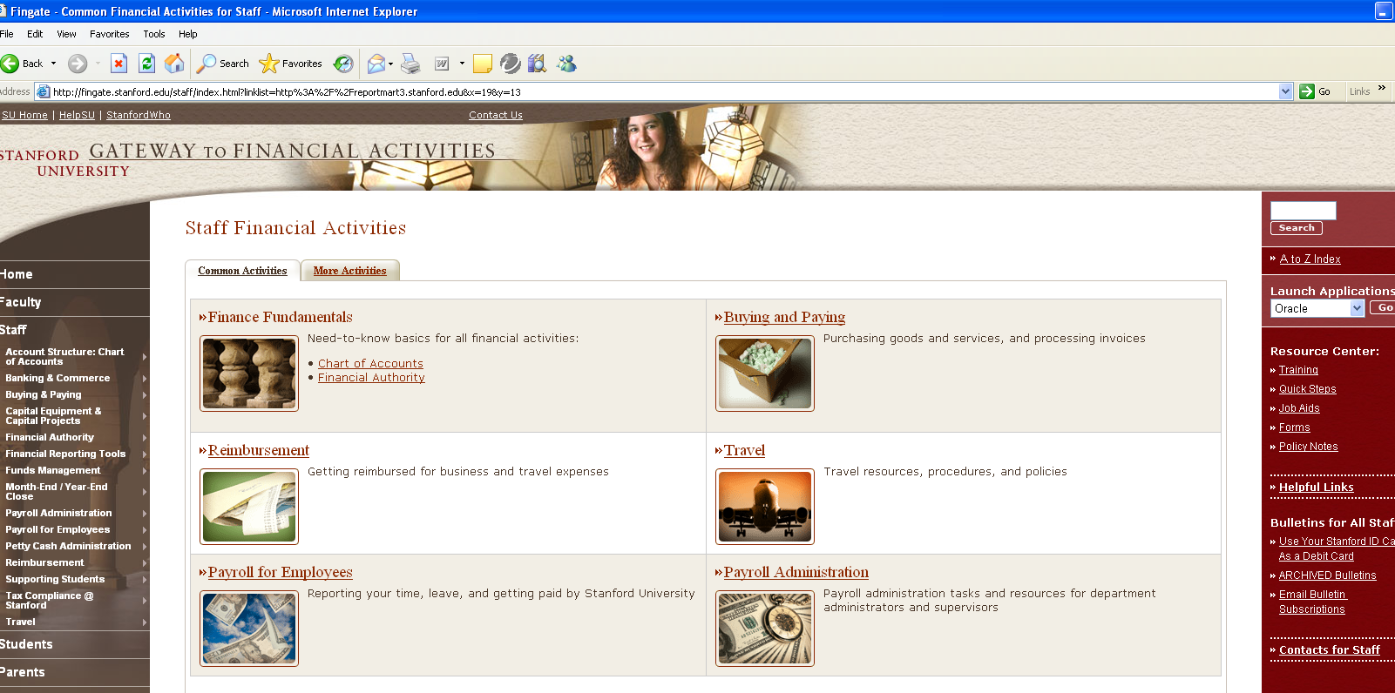
Application Page

You should now be at the Log In Screen.

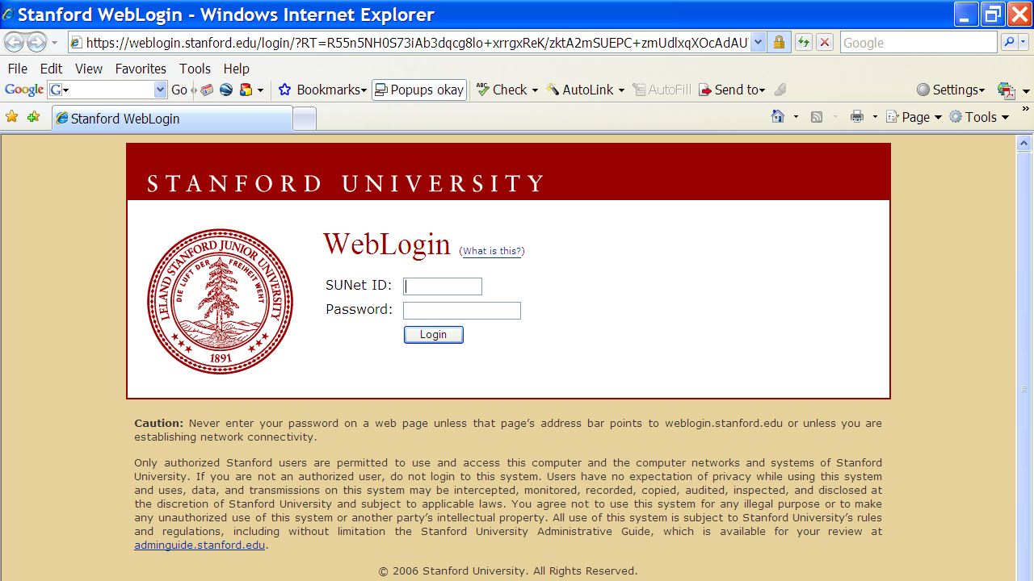
Log In Screen

- Enter your User Name and Password then click [Login].

You should now be at the Main Menu.

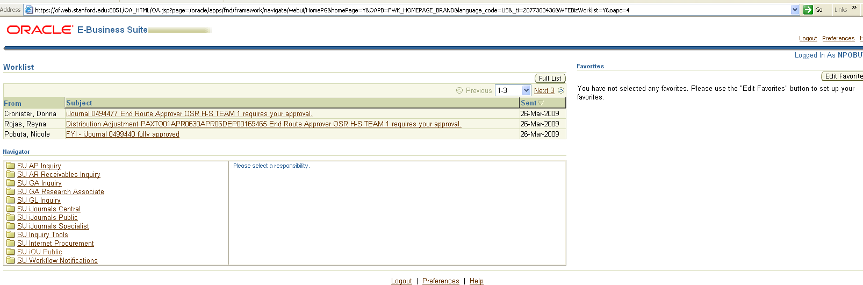
Main Menu

4. Click on SU GA Research Accountant or Associate.

You should now see additional choices.

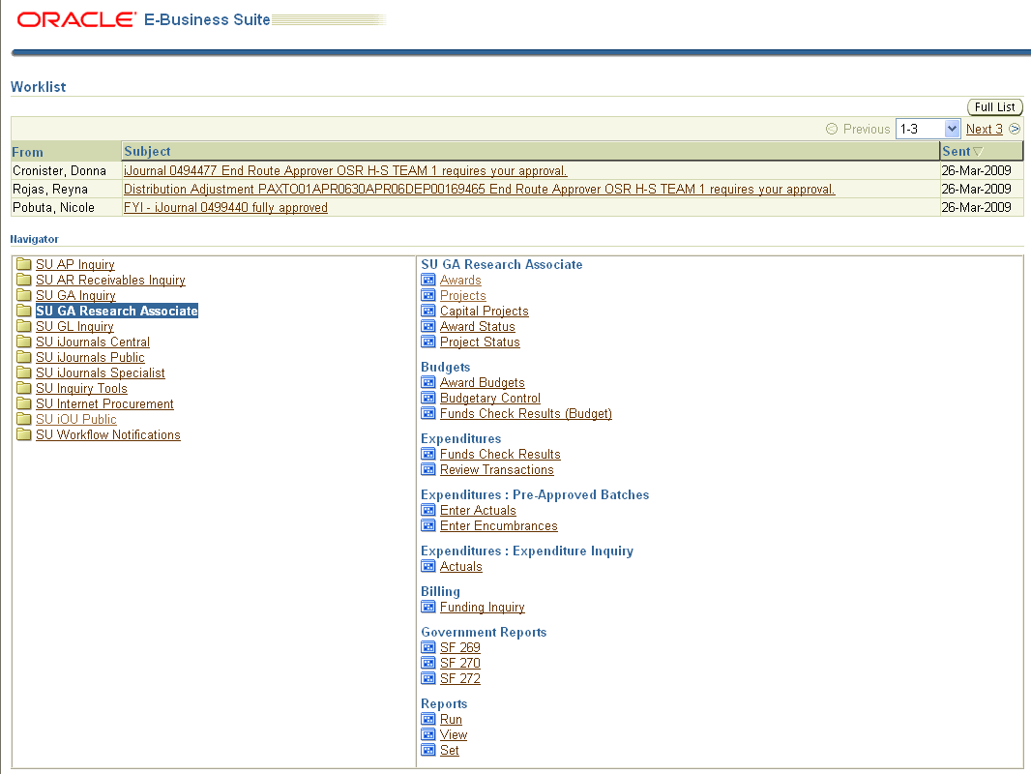

Project Set up

1. Select Projects.
The Find Project window appears.
Find Projects Window

2. To create a new project, choose a sponsored project template by selecting “Templates” from the drop-down list in the [Search For] Field:

- To narrow your search to sponsored project templates only, type in SP% in the Number field and click [Find].

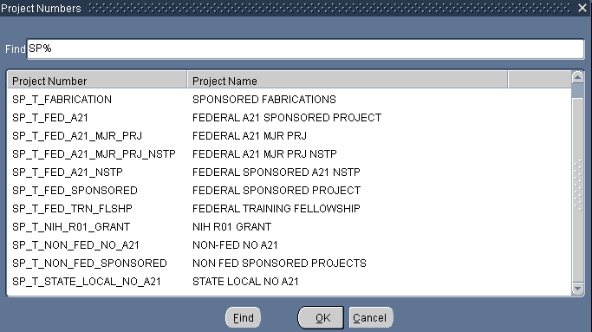
Project Number Find Window

Refer to Exhibit AF “Selecting the Correct Project Template” to choose the correct project template.

NOTE: The following project templates are end-dated and may not be used: SP_T_FED_SPONSORED, SP_T_NON_FED_SPONSORED and SP_T_NIH_R01_GRANT.

- Select the sponsored template and click [OK].

Project, Template Summary
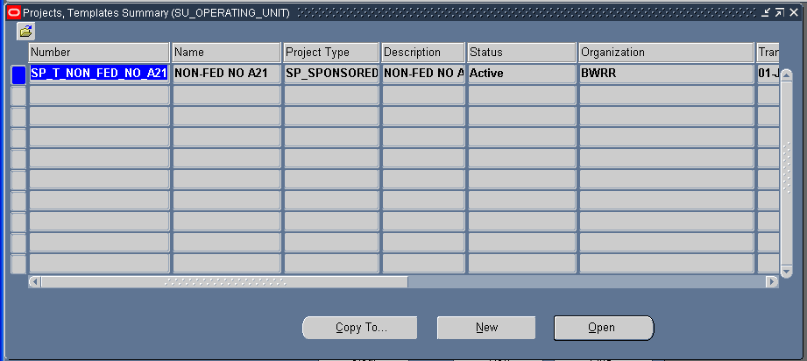
Project, Template Summary Window

- Click [Copy To] button to copy the selected template into a new project.

Project Quick Entry
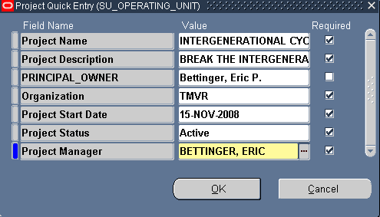
Project Quick Entry Window

The project Quick Entry window allows you to enter information that is required for a new project in a simple form.

- Complete the Project Quick Entry window as described below.

- Project Name
- Unique, descriptive name. Default to award title. Department can modify. Limited to 30 characters alphanumeric.
- See PTA request form.
- Project Description
- Longer description of the project. Default to award title. Department can modify. Limited to 240 characters alphanumeric.
- See PTA request form or use the Award Title.

- Project Principal Owner
- PI name listed on notice of award. (Enter last name first, first name last. Ask for SUNET ID no. if duplicate names.)
- Organization
- Project-owning organization manages the project for reporting and Auto Accounting.
- See PTA request form.
- Project Start Date
- Date work begins.
- Use start date on notice of award or pre-award date (ex. 90 days allowed by NSF)
if allowed by agreement or institution
NOTE: In the case of Early Awards, see Early PTA Procedures (See Exhibit J)
Project Status
- Current status of the project.
- Select Active.
- Project Manager
- The name of the person financially responsible for the project and who would reconcile the project. (Remember to enter last name first, first name last.)
- See PTA request form.

- Click [OK] and the Project Quick Entry window closes.

The Project, Template Summary window is displayed again with the new project listed.

8. Click [Open].

Project Template
The Project Temple window appears with a system-generated project number. Record the project number immediately on the PTA request form.
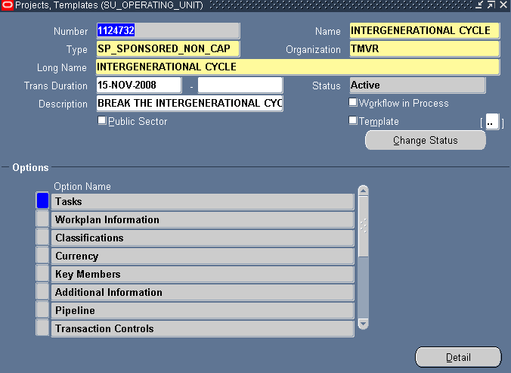
Project Management Window

The Project Template window is used to enter and maintain all of the attributes of a project.
The following information defaults from the Project Quick Entry window:

Number
Name
Type
Organization
Duration (start date only)
Status
Description

DO NOT enter or check the following:

Duration
- DO NOT end date until close out.
Public Sector
- DO NOT check.
Workflow
- DO NOT check.
Template
- DO NOT check.

Project Descriptive Flex Field (DFF)

Click on the DFF button on the Project Template Screen.

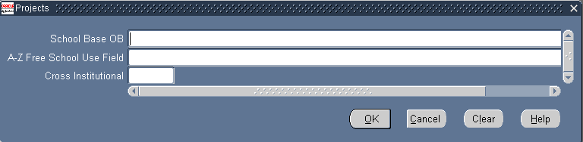
Project (DFF)

Please look at the PTA request form and find out whether or not, the department has identified an A-Z Free School Use Field and enter that information here. (This information should only be one alpha.)

Project Options

Additional information that may be entered into the project setup:

Tasks
Transaction Controls – Only if instructed to do so by Research Accountant.
Asset Information – Property Management will add this information if this is a capital project.
Key Members (PI and Project Manager default from the Quick Entry)

Task Setup

Find Tasks
- Click on the Record or Row Box to the left of the Tasks in the project options, or highlight Tasks and click [Detail].
You should see the Find Tasks window below.
Find Tasks Window
- Click the [Find] button to open the Tasks window.
- If you want to look for one specific task, enter number into [Task Number] Field , and click [Find]

Tasks
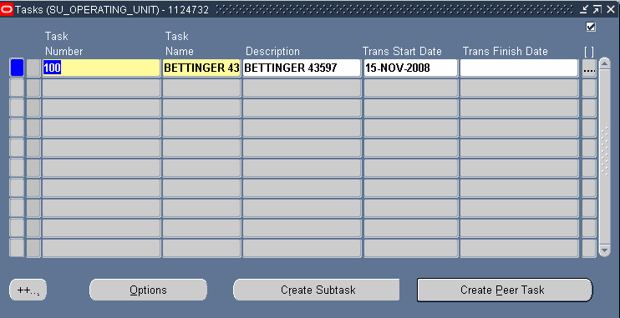
Tasks Window
Every project must have at least one task, but there is no limit to the number of tasks a project may contain. Tasks can be created in a hierarchy of peer tasks and subtasks.

Reporting can be done at all task levels, budgeting can be done at either the top or the lowest task levels, but transactions can only be entered at the lowest task.

        - Task Number
- Unique within the project and cannot be changed after charges are made against the task.
There is no strict naming convention, but if department requests guidance, encourage naming convention of 100, 200, 300, etc. (If there are subtasks under a task, encourage naming conventions of 100.1, 100.2, 100.3, 200.1, 200.2, etc.-OSR DOES NOT USE THESE)
- See PTA request form.
NOTE: In the case of Fabrication please refer to the Fabrication Procedure. (See Exhibit K)
- Task Name
- Short description of task. Department can modify.
- See PTA request form.
- Description
- Optional and provides a place to more fully identify the task.
- See PTA request form.
- Start Date
- Defaults from project quick entry window.
- Completion Date
- Enter the end date.

Descriptive Flex Field
- Click on the Descriptive Flex Field (DFF) next to Completion Date.
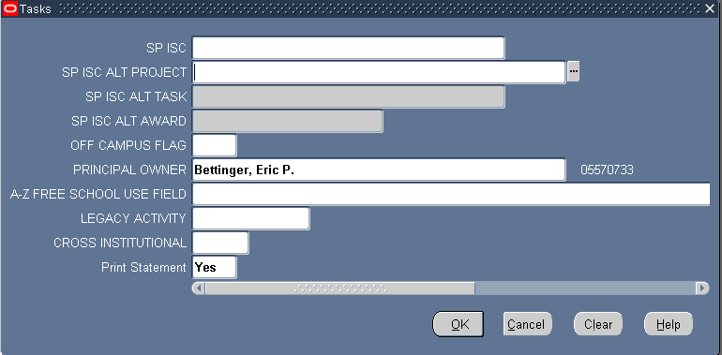
Descriptive Flex Field Window (DFF)

- Enter following applicable information: (See Exhibit AB)
  - SP_ISC
- This only applies to those sponsored projects, which have an indirect cost rate of less than 6%. Choose from the list of values.
- See PTA request form.
- (Unless Award is Provost_Exempt)
  - SP_ISC_ALT_PROJECT
- Alternate project that will capture the 6% infrastructure charge, if it is before 9/1/05. If it after 9/1/05, Infrastructure charge is 8%.
- See PTA request form.
  - SP_ISC_ALT_TASK
- Alternate task that will capture the 8% infrastructure charge.
- See PTA request form.
  - SP_ISC_ALT_AWARD
- Alternate award that will capture the 8% infrastructure charge.
- See PTA request form.
  - OFF_CAMPUS_FLAG
- Write yes in this box if this project is off campus.
  - PRINCIPAL_OWNER
- PI responsible for this task. (Remember to enter last name first, first name last.)
- See PTA request form.
  - A-Z_FREE_SCHOOL_USE_FIELD
- Schools have the option of using this field.
- See PTA request form.
  - CROSS INSTITUTIONAL
- Enter from ePTA form.
i. PRINT STATEMENT
- Enter from the ePTA form. This is at the discretion of the department administrator.

- Click the [OK] button when done.

SAVE

Task Options

- Select the Task you further want to define by clicking on the Record or Row Box to the left of the Task. You can also click on [Options].

Task Options Window
Task Detail
Transaction Controls – Only if instructed to do so by Research Accountant.

Task Detail
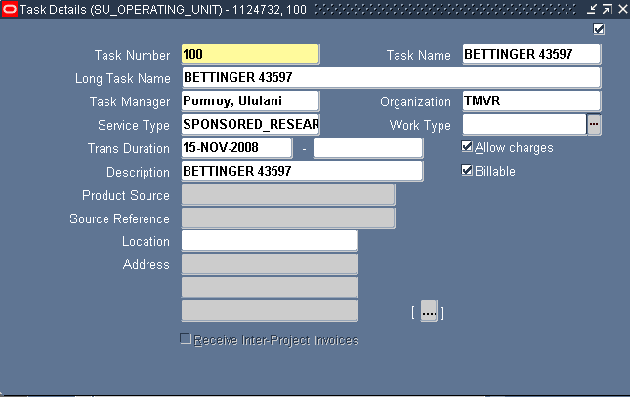
Task Details Window

Some information is brought down from the project and parent task.

16. Enter or change information in this window as needed.
        - Task Number
- Defaults from Task window.
        - Task Name
- Defaults from Task window.
        - Long Task Name
- Optional. Use project name from NOA if nothing marked on ePTA.
        - Task Manager
- Required field. (Remember to enter last name first, first name last.)
- See PTA request form.
        - Organization
- Task-Owning organization responsible.
- See PTA request form.
- Service Type
- Type of work performed on the task. Required by University Policy.
- Must change service type from Undefined using the list of values. (See Exhibit A)
NOTE: Please look at the procedures attached for Cost Sharing (See Exhibit L), Fabrication (See Exhibit K) and/or University Research (See Exhibit M).
- Work Type
- Do not enter any information in this field.
- Duration
- Do Not enter end date (except on NIH T-Grants).
- Description
- Defaults from Task window.
- Allow Charges
- When checked-signifies that expenses may be charged to the task. DO NOT UNCHECK
- Check box.
NOTE: In the case of Fabrication, please refer to Fabrication Procedures. (See Exhibit K)
- Billable
- When checked-indicates that expenditures charged to the task are eligible for revenue accrual and billing.
- Box should always be checked except for University Research and Cost Sharing. DO NOT UNCHECK under any other circumstances. Billing should be controlled at the installment level in all other circumstances.
- Location
- Do not enter any information here.

SAVE and close window.

Transaction Controls: (REFER TO PROJECT TEMPLATE TRANSACTION CONTROL DOCUMENTATION)

ONLY enter transaction controls if instructed to do so by Research Accountant.

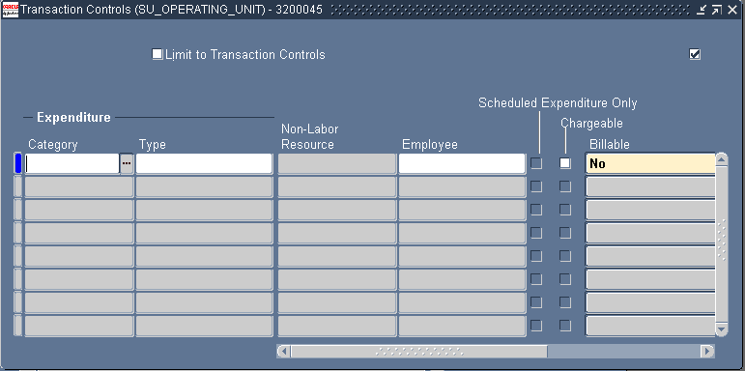
Transaction Controls Window

When an award is setup it is assigned an Allowed Cost Schedule that defines allowable expenditure items.
Transaction Controls can be used at the project or task level to further restrict the Allowed Cost Schedule.

  - Limit to Transaction Controls
- If checked, expenditure items listed are allowed but are restricted to the Employee or Effective Dates entered.
If not checked, expenditure items are not allowed, even if the Allowed Cost Schedule listed them.
  - Category
- Select category using the list of values.
  - Type
- Using the list of values select the type.
  - Employee
- Enter name of employee. (Remember to enter last name first, first name last.)
  - Chargeable
- Check box if you would like to make this transaction chargeable.
  - Billable
- Options: No, Task Level
  - From
- Enter date.
  - To
- Enter date.

Note: See Exhibit K for Fabrication Tasks.

Key Members
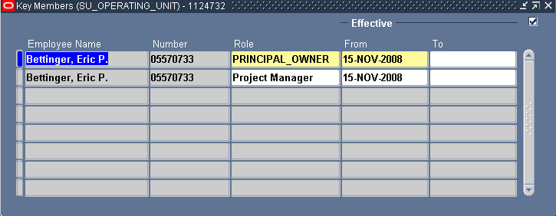
Key Members Window

Principal Owner and Project Manager are required roles per University policy. The Manger role drives the Authority rules to determine who can look and act on the project. This should default from the Quick Entry screen.

Key member information includes:

        - Employee Name
- Enter employee name. (Remember to enter last name first, first name last.)
        - Number
- Once an employee is entered, the number will populate.
        - Role
- Choose the role from the list of values: Project Manager, etc.
        - From
- Defaults to start date.
        - To
- Do not add an end date to an active Owner or Manager if they will not be replaced. Add end date before adding a new Principal Owner or Project Manager.

SAVE and exit back to the Navigator window.

END OF ACTIVITY.

Award Setup

- Go back to the navigator window and select Awards.
The Find Award window appears.
Find Award

- Before you begin :
- You must decide on an Award range and number (see Exhibit B). After you determine the range choose a unique award number and enter into [Number] field and click [Find] to verify availability.
- You should also verify the correct sponsor customer number (See Exhibit AD)

- To create a new award based on an existing template or an existing award, choose one of the following from the drop-down list in the Search For Field:

Templates
Awards
Template, Awards

- To narrow your search, type SP% in the Number Field and click [Find]. This will allow you to see Sponsored Project Templates only.

Award Number Find Window

- Select the Template and click [OK]

Award Management Folder

The Award Management Folder window appears.

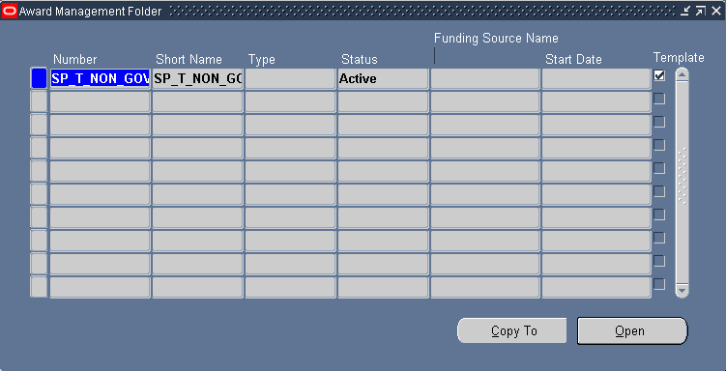
Award Management Folder Window

- To enter a new award, select a template or award to copy as the basis for the new award and click [Copy To].
The Award Quick Entry window appears, which contains all the information required to setup an award.

Award Quick Entry

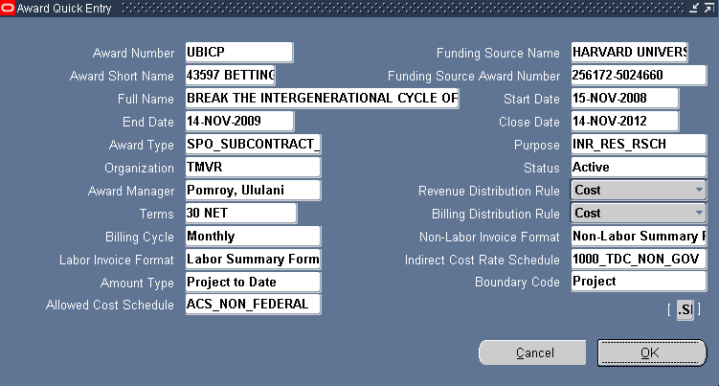

Award Quick Entry

- Enter or modify data in each field of the Award Quick Entry window.

- Award Number
- Award number CANNOT be duplicated of an existing award or project number.
- To find the next available award number, please go to the following URL: Exhibit B.
- Funding Source Name
- Legal sponsor name. This list is managed by Accounts Receivables. (See Exhibit AD)
- See noticed of award. This must be the institution to be invoiced (not the prime sponsor).
NOTE: Please refer to the attached procedures for the following: Cost Sharing (Exhibit L) and University Research (Exhibit M).
- Award Short Name
- This field is 30 characters long (alphanumeric).
- See PTA request form. The first six digits are reserved for the SPO number. Department can modify thereafter.
NOTE: Please refer to the attached procedures for the following: Cost Sharing (Exhibit L) and University Research (Exhibit M).
- Funding Source Award Number
- Number assigned by the sponsor, for example, 5P30-CA44579. This will appear on the invoice.
- For NIH this will be the document number. Add the appropriate prefix (example: “8-“).
- For University Research use the awarding offices identifying number.
- For Clinical Trials, enter the Protocol or Contract number.
- If no number is available, enter the SPO# (i.e. SPO# 12345)
- See notice of award. Always use the number that the sponsor requires on the invoice.
NOTE: Please refer to the attached procedures for the following: Cost Sharing (Exhibit L), University Research (Exhibit M) and Early PTA (Exhibit J).
- Award Full Name
- This field is 240 characters long (alphanumeric).
- Award title listed on the notice of award.
NOTE: Please refer to the attached procedures for the following: Cost Sharing (Exhibit L).
- Award Start Date
- Start date as shown on notice of award.
NOTE: Please refer to the attached procedures for the following: Early PTA (Exhibit J).
- Award End Date
- For those sponsors with expanded authority, the end date will be the end date of the competitive segment. (NSF, NASA, some NIH, and some foundations)
- For sponsors who DO NOT allow carry forward, use the budget period end date. Please refer to the attached procedures for the following: Early PTA (Exhibit J), No Cost Extension (Exhibit N) and Extended Request (Exhibit O).
- Award Close Date
- This is the date the award is no longer active. Expenditures CANNOT be charged to an award after this date, but adjustments can be made within the start/end date period.
- Three years after the award end date.
NOTE: Please refer to the attached procedures for the following: No Cost Extension (Exhibit N)
- Award Type
- Type of award you are setting up. (i.e. federal grant) (See Exhibit C)
NOTE: Please refer to the attached procedures for the following: University Research (Exhibit M)
- Award Purpose
- Research, Instruction, OSA, etc. (See Exhibit D)
- See notice of award.
NOTE: Please refer to the attached procedures for the following: University Research (Exhibit M) and Cost Sharing (Exhibit L).
- Organization
- Organization which award is assigned to.
- See PTA request form.
- Status
- A status of “Active” allows expenditures to post to the award and billing/invoicing to occur. The status will default in from the template, but it can be changed.
- A status of “At Risk” allows expenditures to post to the award, but does not allow billing/invoicing to occur. This status is typically used for early awards and during award closeout.
- A status of “On Hold” prevents expenditures from posting to the award, but billing/invoicing to occur.
- A status of “Closed” prevents expenditures from posting to the award and does not allow billing/invoicing to occur. This status will be used once an award has been closed out.
- The Award Status can be modified at any time (except during Month-End Close Black-Out).
NOTE: Please refer to the attached procedures for the following: Early PTA (Exhibit J).
- Award Manager
- Person who provides administrative and financial management for award. (Remember to enter last name first, first name last.)
- See PTA request form.
- Revenue Distribution Rule
- Two choices: Cost or Event. (See Exhibit E)
- Cost rule will generate revenue based upon actual costs posted to the award.
- Event rule will generate revenue based upon the events that are marked with a revenue flag.
- Contact AR if you have any questions regarding the correct choice.
- Terms
- LOC awards = Immediate. All others are 30 days. See award requirements for other choices.
- Billing Distribution Rule
- Two options: Cost or Event. (See Exhibit E)
- Cost based awards are used to keep track of expenses as they occur and bill the sponsor based on these expenses.
- Event based awards are used to bill sponsors based on milestones or events, rather than actual costs, such as signing up a specified number of patients for a clinical trial.
- Billing Cycle (See Exhibit Z)
- For letter of credit (LOC) choose Daily.
- For non-letter of credit check contract or grant terms.
- For clinical trials choose Monthly.
- Awards that might need billing at a less than monthly frequency, set to “Monthly”.
- Non-Labor Invoice Format
- Choose Non-Labor Summary Format.
- Labor Invoice Format
- Choose Labor Summary Invoice Format.
- Indirect Cost Rate Schedule
- Choose from the list of values. See Application of F&A Rates at Stanford: https://orasecurestanford.stanford.edu/supporting_files/rate_app.pdf (See Exhibit AB)
- Amount Type
- Beginning period used for funds check to calculate the available budget.
- Choose Project to Date.
- Boundary Code
- Ending period used for funds check to calculate the available budget.
- Choose Project.
- Allowed Cost Schedule
- The ACS defines which expenditure types that can be charged to the award.
- Choose the correct allowed cost schedule by identifying the Funding Source Name and the Award Type. (See Exhibit F)
NOTE 1: The ACS CANNOT be changed after the award has been set up.
NOTE 2: Please refer to the attached procedures for the following: University Research (Exhibit M).

Award Descriptive Flex Field (DFF)
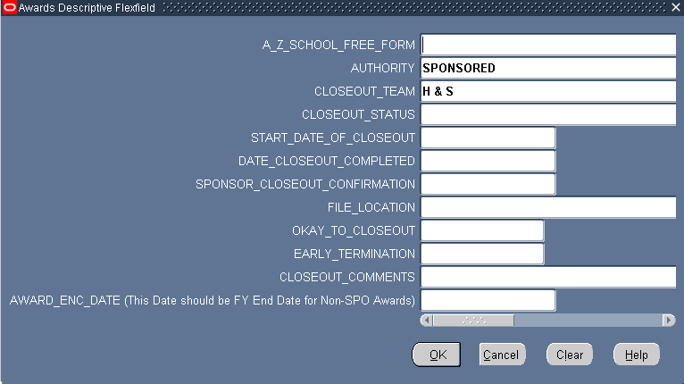
Award Descriptive Flex Field (DFF)

Enter Closeout_Team name (Medicine, H & S, Engineering) and click [OK].

7. Click [OK] on Award Quick Entry window.

8. To view or modify an existing award, select the award and click [Open].
The Award Management window appears populated with the data entered in the Award Quick Entry.

Award Management Window
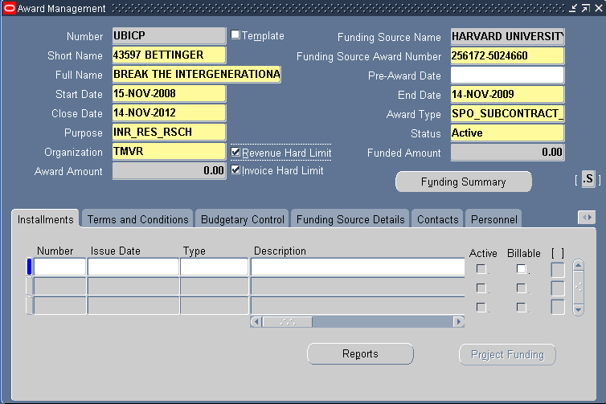
Award Management Window

- Please be sure the Revenue Hard Limit Box and Invoice Hard Limit boxes are always checked on award management window.
- Pre-Award date. Must also be the Project and Task Start Date. (See Exhibit J) Use per Terms & Conditions.
- Select the Descriptive Flex Field (DFF) by clicking on the button next to the Funding Summary button in the Award Management Window.

Installments

Select the Installment tab.
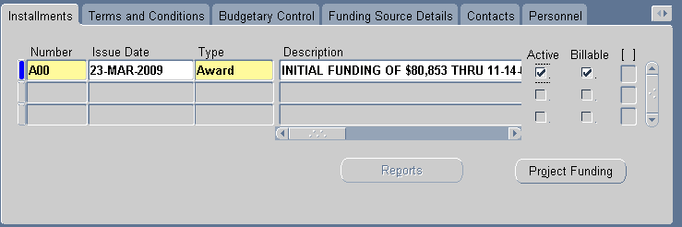
Award Installments

An Installment defines the dollar amount that may be billed. A separate non-billable installment should be used for funding that cannot be billed.

Users can enter and track the following information in the Installment tab of the Award Management Window:

a. Number
- The naming convention for the installment number is the modification/amendment number per sponsor. If there is no modification/amendment number please use year funded or A01.
NOTE: This field is alphanumeric.
b. Issue Date
- Effective date of award/modification.
c. Type
- Three choices: Amendment, Award, Supplement
- Amendment is a non-financial charge to an award which doesn’t allow users to enter an amount or check the Active or Billable check boxes.
- Award is the original funding.
- Supplement is additional award funds.
d. Description
- This is a short description for the purpose of the installment.
e. Start Date
- Same as start date of award.
f. End Date
- Date installment is no longer active. Normally, the same as the award end date.
g. Close Date
- Same as close date of award.
h. Direct Cost
- Enter full awarded amount. (Remember to not use commas when entering dollars.)
i. Indirect Cost
- Leave this blank.
j. Active
- Active box has to be checked in order for expenses to be spent against the award. Once the active box is checked, the installment amount will be automatically populated in the award amount and funded amount field on the award management screen. If the active box is not checked, the installment amount will be populated in the award amount field, but not in the funded amount field. Restricted installment: carry-forward installment waiting for approval; installment for option on federal awards; etc.
k. Billable
- Billable box has to be checked for billing to be generated. The billable box on early award, cost sharing award or internal University Research award should not be checked. Also, the billable box should not be checked on installment that has carry-forward amount waiting for approval, restricted funding amount, interest (EFP) or option that is not exercised yet.

Project Funding
When the active box is checked, the Project Funding button becomes activated.
Click [Project Funding].

Project funding is an allocation of funding from an award to a project or top task.

The Fund Projects window allows users to fund the amount of the installment to the project or top task level.

An installment must always fund a project at the same level. For example, if an installment funds the project at the project level, the subsequent funding for that installment must also fund at the project level not the task level.

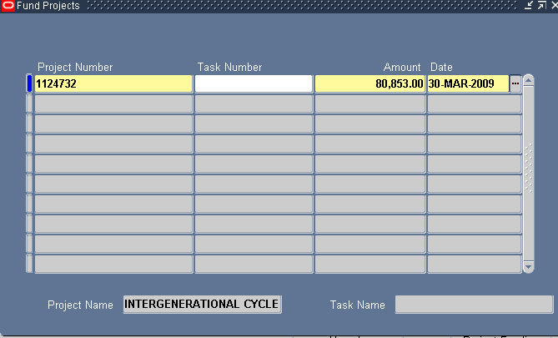
Project Funding Window

To fund projects, perform the following steps:

a. Project Number
- Select project number.
b. Task Number
- DO NOT enter a task number on the sponsored award.
- Only Cost Sharing should be funded at the Task Level.
c. Amount
- Enter installment amount. (Remember to not use commas when entering dollars.)
d. Date
- This defaults to current date.

SAVE and close window.

Terms and Conditions
Select the Terms and Conditions tab.
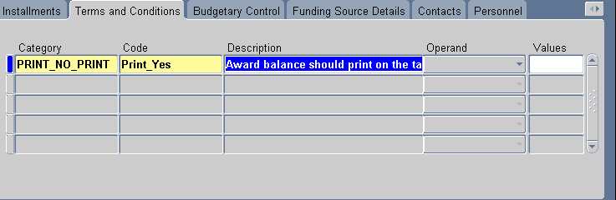
Award Terms and Conditions

Enter or modify data in each field of the Terms and Conditions tab as described below. Some award templates have pre-selected Terms & Conditions. (See Exhibit G for a list of all Terms and Conditions.)

a. Category
- Items listed in category list of values are defined when users setup award terms and conditions.
- See Terms and Conditions attachment on PTA request form.
b. Code
- Terms and Conditions name.
- See Terms and Conditions attachment on PTA request form.
- Description
- Terms and Conditions description. (This defaults as soon as you select the code.)
- Operand
- Operand for Terms and Conditions: select Less than, Greater than, Equal, Not equal, or N/A.
NOTE: This field is for information only.
- Value
- Value for Terms and Conditions: numeric field

SAVE

Budgetary Control

Select the Budgetary Control tab.

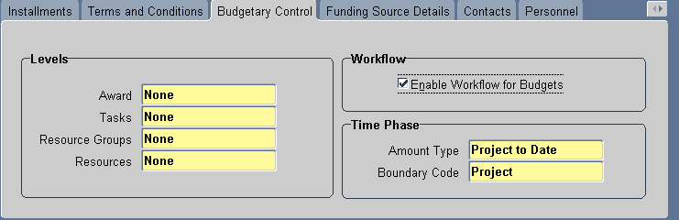
Award Budgetary Control

Budgetary Control is the process of applying actual and encumbrance transactions against a funding budget to determine funds available in order to control spending on an award budget.

The options for budgetary control settings are as follows: Absolute, Advisory, None.

Absolute – If absolute is entered, the transaction is rejected unless funds are available.
Advisory – If advisory is entered, the transaction is approved even when no funds or insufficient funds are available.
None – If none is entered, all transactions are approved and there is no funds check.

Enter or modify data in each field of Budgetary Control tab as described below.

a. Levels
- Award – None
- Task – None
- Resource Group – None
- Resources – None
b. Workflow
- Check box (system will not allow to check if award has future start date)
c. Time Phase
- Defaults from award quick entry.

SAVE

Customer Address

Select the Customer Address tab.

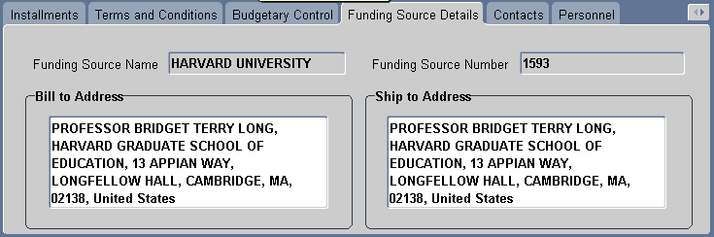Award Sponsor Address

The customer name and address will default once a Funding Source Name is entered in the Award Quick Entry window. To change the address, place the cursor in the address box, and click Ctrl+L, to see the other choices.

You CANNOT edit the Bill to and Ship to Address. Please contact AR to add/edit a new Customer Address.

Contacts

Select the Contacts tab.
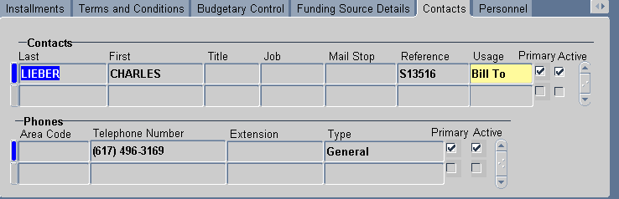
Sponsor Contacts

Contacts default once a Funding Source Name is entered in the Award Quick Entry window. You CANNOT change.
If a change needs to be made to Contacts, please contact Accounts Receivable.

Personnel

Select the Personnel tab.
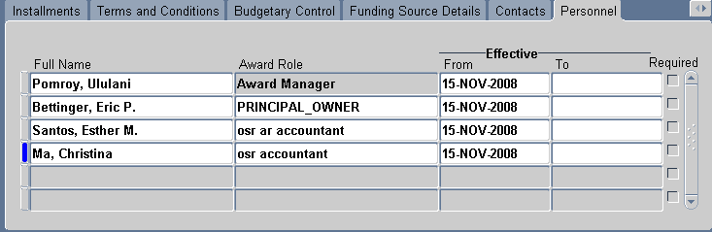 Award Personnel

The Award Manager and Principal Owner roles are required fields per SU policy. The Award Manager role will default from the Award Quick Entry window.

If the award manager or PI changes during the life of the award, DO NOT delete the name. End date and then add a new line with the new personnel information and the new start date.

See AR instructions for adding the AR representative. The OSR Closeout Accountant should be added at closeout.

SAVE

Compliances
Select the Compliance tab.
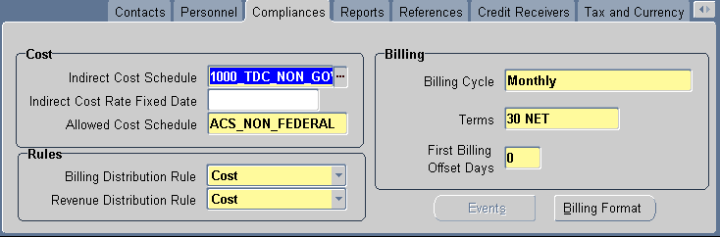
Award Compliances
Information defaults from the Award Template and the Award Quick Entry form.
- First Billing Offset Days: This specifies the first billing to be due for this award. Enter for Cost/Cost awards.

Multiple Burden Schedules (See Exhibit Q)
Attach NOA (See Exhibit AC)

Billing Format (See Exhibit Z)

Reports
Select the Reports tab 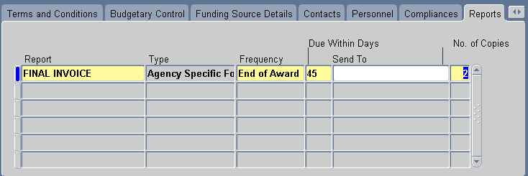
Award Reports
Enter data in each field of the Reports tab as described below.
a. Reports
- Select from the LOV.
b. Type
- Defaults as Agency Specific Form.
c. Frequency
- Annually, Quarterly, End of Award, End of Installment, Monthly, Quarterly.
d. Due Within Days
- Enter the number of days after the specified frequency. These dates are calculated based on Award start/end dates.
e. Send To
- Choose from the LOV.
f. Number of Copies
- This is the number of copies of the report that are needed. For example, you might need a copy for the funding source, one for the file, one for internal reporting, etc.

NOTE: Reports are installment driven. Generated due dates are driven by frequency, due within days, and the start and end date of the installment.
NOTE: If interim reports are required they must be added to COFR.
SAVE

References
Select the References Tab.
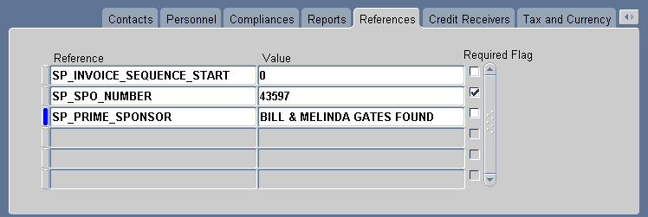
Award References
Enter data in each field of the Reference tab. (See Exhibit H for a list of all References.)

a. References
- Choose from the LOV as they apply to the award.
- SPO# - Required on all sponsored awards with a SPO number.
- CFDA# - Required on all Federal Grants.
b. Value
- Type information as it applies to the reference.

SAVE
DO NOT close window.

END OF ACTIVITY

Budgeting Awards

After you have set up the award, choose Tools from the menu above and select Award Budgets. This will take you directly to the Award Budgets screen.
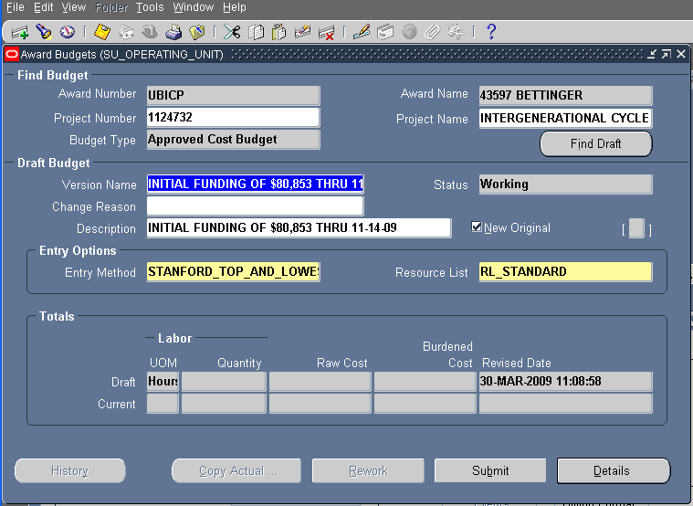
Award Budgets Window

An award budget is a detailed estimate of the cost of that portion of a project funded by a particular award.

1. Click [Find Draft]

2. Enter the following information:

a. Version Name
- Enter Version Name (discretionary verbiage)
b. Description
- Enter the description (discretionary verbiage)

3. Click [Details] and the Task Budgets window appears.

Task Budgets Window
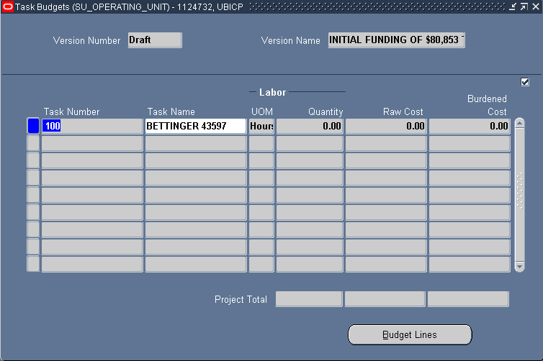
Task Budget Window

Remember you can only fund at the highest or lowest task levels.

4. Click [Budget Lines] and the Budget Lines window appears (if there are multiple tasks, highlight the appropriate task).

Budget Lines Window
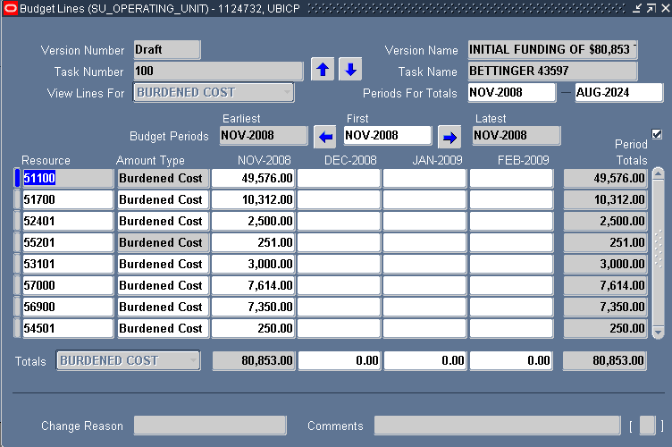
Budget Lines Window

5. Enter the following:

a. Resource
- Enter expenditure type. (See Exhibit I)
b. Amount Type
- This will always be Burdened Cost

c. On the 1st available month, enter budget amount for the resource.

SAVE

Close the Budget Lines window.

If you are budgeting multiple tasks, move your cursor to the next task you want to budget in the Task Budgets window and repeat the above steps.

When you have finished budgeting, save and close the Budget Lines window and Task Budgets window. The Award Budgets window will appear.

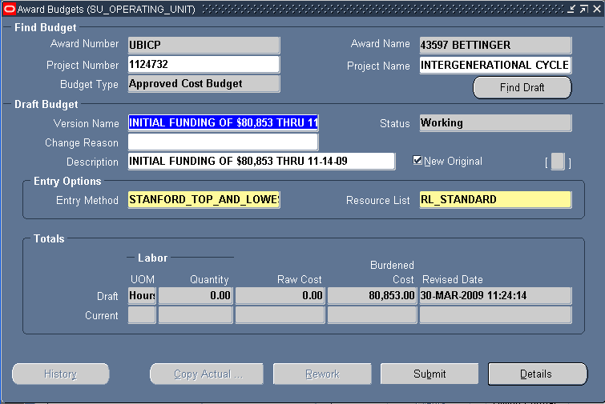
Award Budgets Window

6. The Accountant will Submit/Baseline simultaneously. (If the Workflow box is unchecked-click [Submit]-once selected, the [Submit] button changes to [Baseline].)
If at this point you decide to make a budget line change you can do so by selecting [Rework]. This changes status from submitted to working.
Note: You approve a budget when you baseline the award budget.

NOTIFY DEPARTMENT OF THE PROJECT TEMPLATE USED TO SET UP ORACLE PROJECT

After the PTA has been set up, the ORA setup accountant will inform the award manager of the Oracle project template used to set up their project(s).

- Cut and paste the information from the MS Word document at Exhibit AG: “Notice to Department After Setup” into an e-mail.
- Replace the information in brackets and enter the project number(s) next to the project template(s) used to set up the Oracle project(s).
- E-mail to award manager

END OF ACTIVITY

