TASK BURDEN SCHEDULE OVERRIDE

When there is more than one burden schedule that applies to an award you will need to do a Task Override Schedule. This is done at task level.

For each task that requires a different burden rate go to the Tools tab of the Award Management Screen and click on Override Schedules.

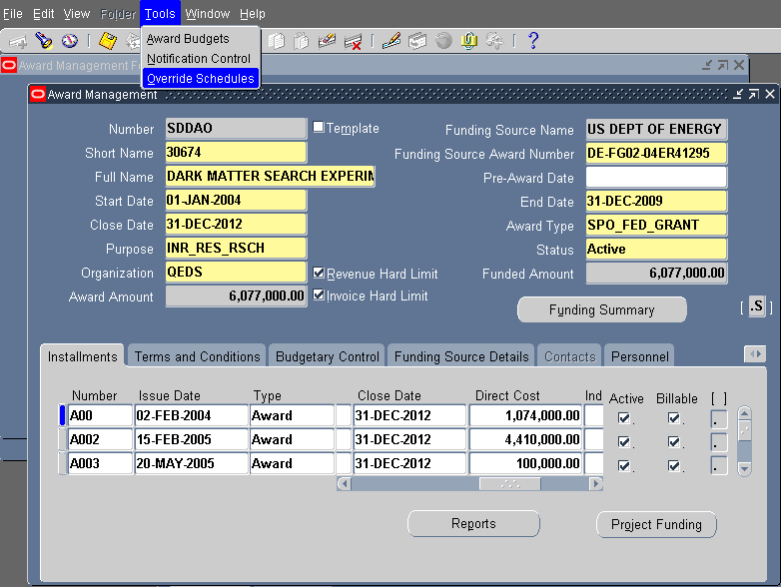

Enter the Project number, the Task(s) requiring the override, and the appropriate Burden Schedule. (DO NOT enter a Fixed Date)

