Choosing the Correct Funding Source

Sponsored vs Non Sponsored Funding Source Names

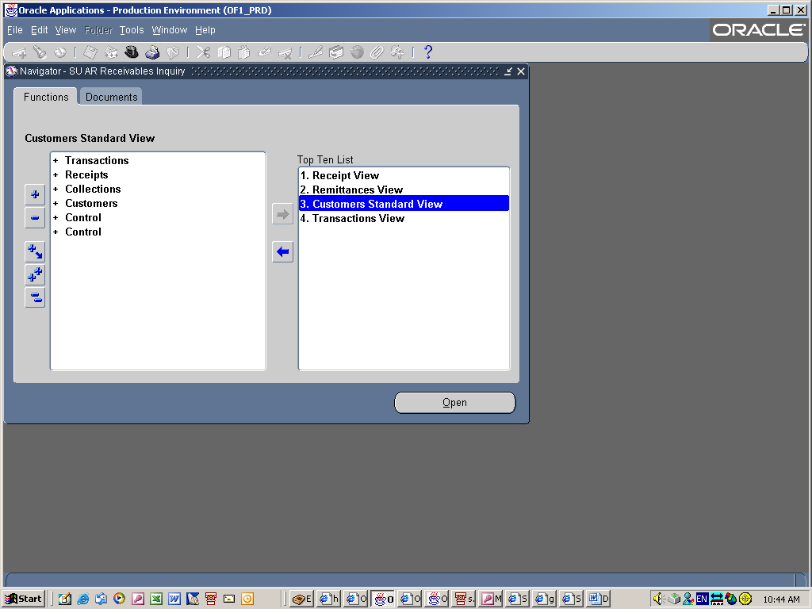

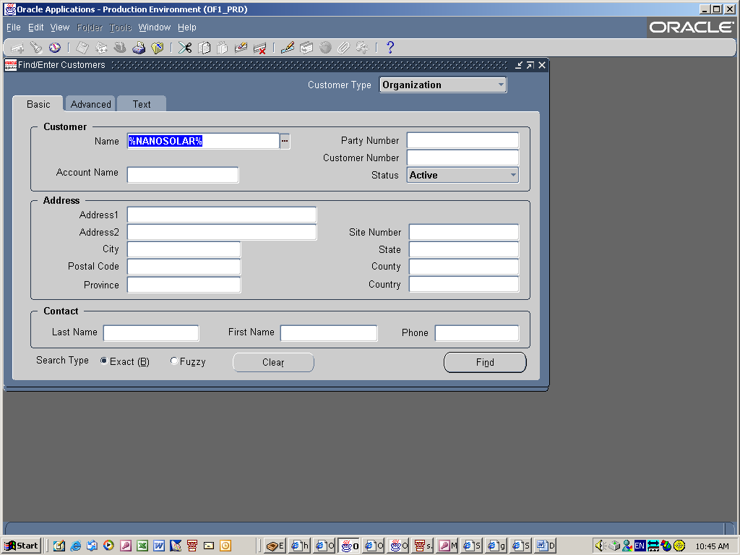
Search for your Funding Source. Normally good idea to use as few letters as possible with wild cards on each end to find your Funding Source name. This will bring up the most options.

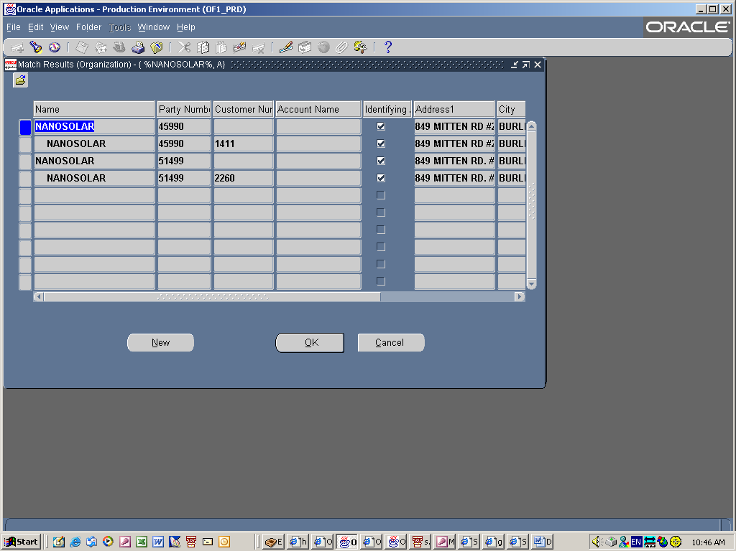

Two funding source names appear. Review both and look for the one that is classified as ‘Sponsored’.

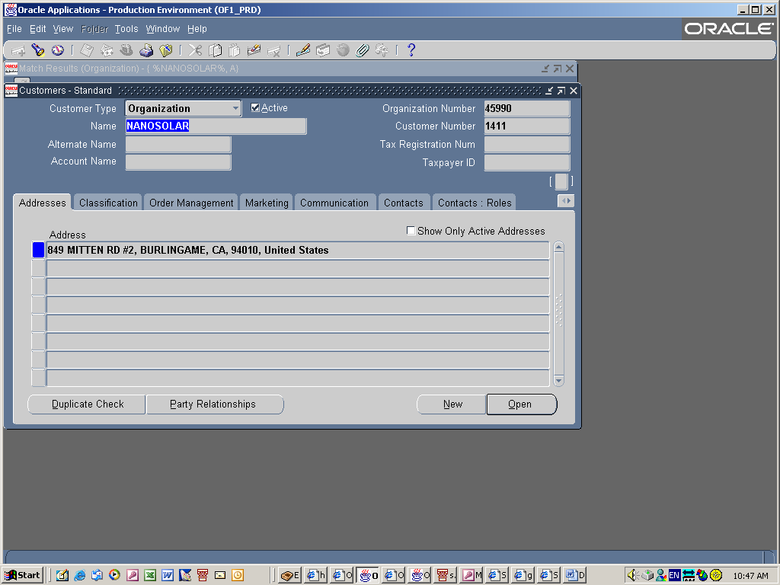

Choose the classification tab
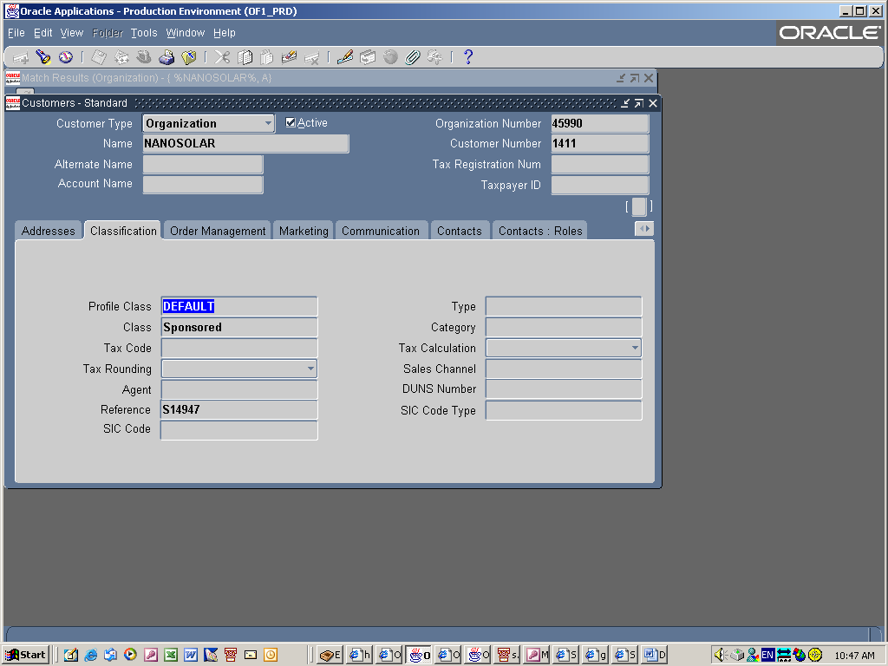

This Funding Source is classified as Sponsored
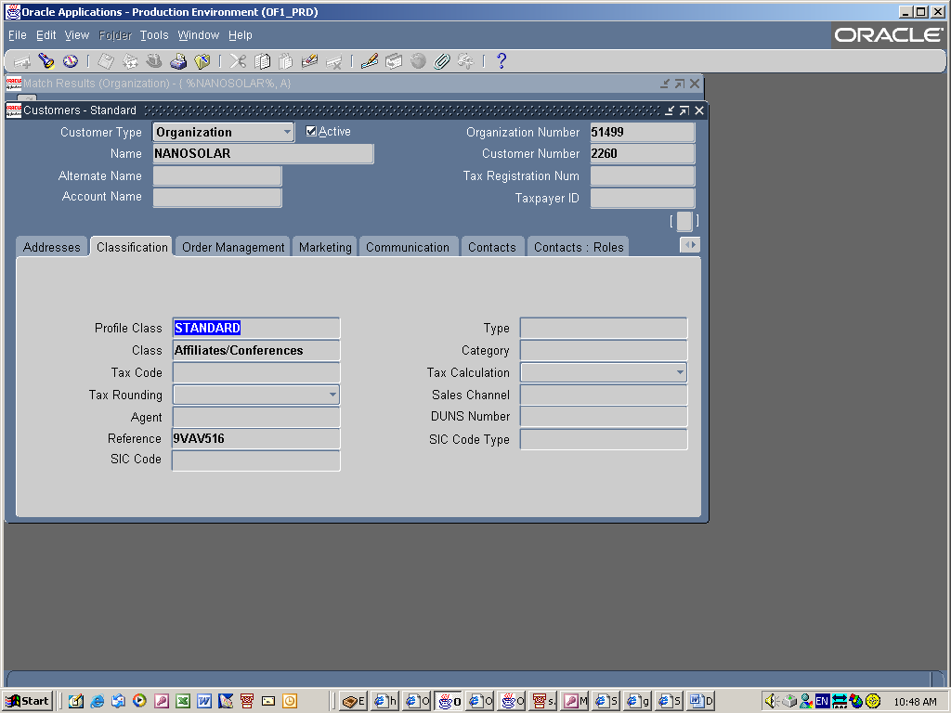
This Funding Source is classified as ‘Affiliates/Conferences’. This is a NON SPONSORED funding source name. Do not use this one.

