COST SHARING PROCEDURES

When setting up Cost Sharing account please remember that we use the same Project as the sponsored project. Add a new Cost Sharing Task to that Project and create a new Cost Sharing Award. Project Funding for cost sharing should be done at the task level.

Overdraft cost-sharing may not be transferred to, or combined with, committed cost sharing awards. A separate overdraft cost sharing award must be opened.

Please refer to the PTA Setup Manual for proper setup, but remember to do the following:

TASK SETUP
Create new Task under the same Project as the Sponsored Project.

Task Number: 700 (or in the 7xx range)

The Task Service Type should be the same as the main award except for
SPONSORED_RESEARCH use UNIVERSITY_RESEARCH

Task Service Type: UNIVERSITY_RESEARCH or
SPONSORED_INSTRUCTION or
OTHER_SPONSORED_ACTIVITY

Task Name: PI-SPO- Type of C/S
SP_ISC Not applicable
Billable: billable box should be unchecked

AWARD SETUP
Create new award in the WAxxx award range.

Choose appropriate template: either committed or overdraft (see description below).

Funding Source Name: STANFORD GENERIC NOT BILLED
(cust # 3307)
Award Short Name: SPO_ Type of Cost-sharing_PI Name
(Ex. 12345_ PI Effort_C/S_Smith)

Funding Source Award Number: “Guaranteed by” [Award Number]
Award Full Name: Describe what the cost sharing is for. (i.e. “PI effort” “Mandatory” or “Overdraft”)
Award Type: SPO_UNIV_FUNDED_AWARD
Award Purpose: INR_COST_SHARE for Cost Sharing
INR_OVERDRAFTS for Overdrafts
Dates: Same as sponsored projects period.
Billing Rules: Event
Revenue Rules: Event
Billing Cycle: None
Indirect Cost Rate Schedule: FB_VA
(Fringe Benefits and Vacation Accrual – Cost sharing is exempt from Tuition Grant Program (TGP) and Graduate Student Stipend)
Allowed Cost Schedule: Same as main award (federal, nonfederal,
state)

Fund amount that is stated on ePTA, or provided by department

TABS

Installment: Active but not Billable
Project Funding: Enter project number, task number and amount

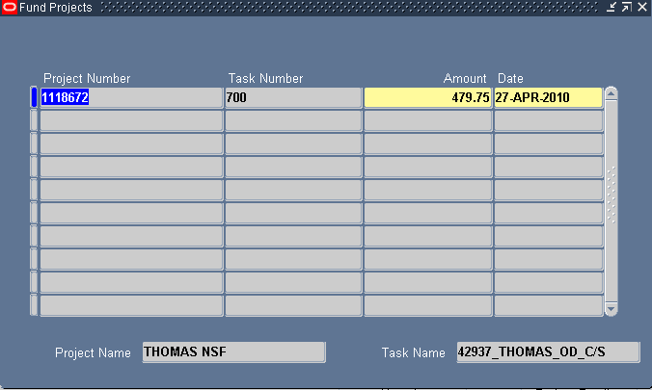

Terms & Conditions: SP_COST SHARING

References: SP_GUARANTEE_AMT

SP_GUARANTEE_AWD

SP_SPO NUMBER

Budget Controls: “NONE” at all levels.

OPTION 1

Committed Cost Sharing
Create installment for amount funded on the cost sharing form. Create the project funding and baseline the budget for this amount. Use Expenditure Type 50001 when budgeting.
If the department chooses to fund cost sharing at the time of the PTA setup, the Associate must ask the Research Accountant to do the funds transfer from department guarantee award to Cost Sharing Award, otherwise account will be funded during Year-End Close utilizing provided guarantee PTA.

OPTION 2

Overdrafts Cost Sharing
Create installment for amount funded on the cost sharing form or per email from department and/or Research Accountant. Create the project funding and baseline the budget for this amount. Use Expenditure Type 50001 when budgeting. The Associate gives the information back to the Research Accountant so that they can do the fund transfer journal during closeout process.

