How to Generate Revenue when the Revenue Rule is Cost
Stanford University policy and GAAP rules require that revenue be recognized at the time it was earned. To comply with this, Fixed-Price Agreements should have the Revenue Rule of COST. If there is a remaining balance on the Fixed-Price Agreement, use this procedure to accrue the final amount of revenue at closeout. Do not follow procedure if revenue has already been fully accrued.

Sponsored projects that require Milestone Billing or a Clinical Technology Assessment Agreements (Clinical Trials) should have a Revenue Rule set to EVENT. This allows Revenue to be generated based upon the completion of a patient visit, procedure, completion of project, or any other fixed-price event that has been identified in the agreement. Use this procedure when an award has a COST Revenue Rule that should have been marked EVENT.

Since the Revenue Rule cannot be changed after revenue has been generated, it is recommended that an award be replaced by a new one with the correct Billing and Revenue Rules. If a significant amount of expenses have already been posted and the award is either closed or soon to be closed this procedure should be used to accrue the final amount of revenue while leaving all expenses on the original award.

OSR Research Accountant:
- Determine the amount of Unearned Revenue to be generated.
  - This will be the unexpended balance amount less indirect costs (see attached Burden Adjustment Guidelines).

OSR Accounting Associate: (see attached slides)
- Setup a new award with same project number and SPO number (status: On Hold)
- Set Revenue Rule to Event.
- Set Billing Rule to Event.
- Set Billing Format to NO PRINT.
- Enter amount determined by Research Accountant in a billable installment.
- Create Project Funding with the existing project number for the same amount.
- Uncheck the ‘Enable Workflow for Budgets’ box on the Budget Control award tab.
- Add attachment under Compliance Tab as a long text. Description: “DO NOT INVOICE–AWARD CLOSED”.
- Baseline Budget at zero dollars.

Accounts Receivable Accountant:
- Create an Event on the new award for the same amount as step 6 for both revenue and billing.
- Run Streamline Billing Process overnight.
- Transfer partial payment for the amount in step 6 from the original award to the new award.

OSR Research Accountant:
- Reverse the original Fund Transfer from the original sponsored award to the PI Income Fund (when previous transfer was completed without utilizing a new revenue generating award).
- Create and route a new Fund Transfer journal (see attached Fund Transfer Guidance) that debits the new sponsored award for the amount determined in step 1 and same project number and credits the PI Income Fund (same PI Income Fund as was originally used if previous fund transfer was reversed).
- Create a new journal to write-up indirect costs (from unexpended balance) to the Original Sponsored Award.

Accounts Receivable Accountant:
- Reduce invoicing on the original award by the amount transferred and billed to new award (invoices should match expended amount including indirect costs write-up).

OSR Accounting Associate:
- Run Fund Statement after month end close for both the original award and the new sponsored award to verify that the Fund Balances are zero.
- Deobligate the new award installment using the Clinical Trials Deobligation Procedures.
- Deobligate original award using Closeout Deobligation Procedures.
- Change award status on both awards to Closed to block additional transactions.
- Go to COFR and under the original award enter in the new award number in the associated field (see slide below).
- Go to COFR under the new award and change the Close Out Status to “CWA Purpose”.

Steps 1-10 and 22

- Find and write down a new award # using the same range as the original award.
- Find the original award
- Click ‘Copy To’
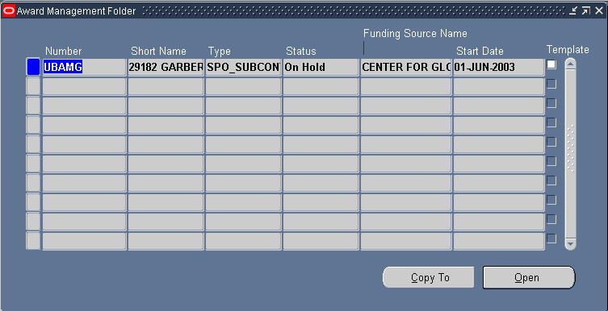

Short Name Format:
SPO# Original Award# “REVENUE RECOG”
- Enter information according to instructions below
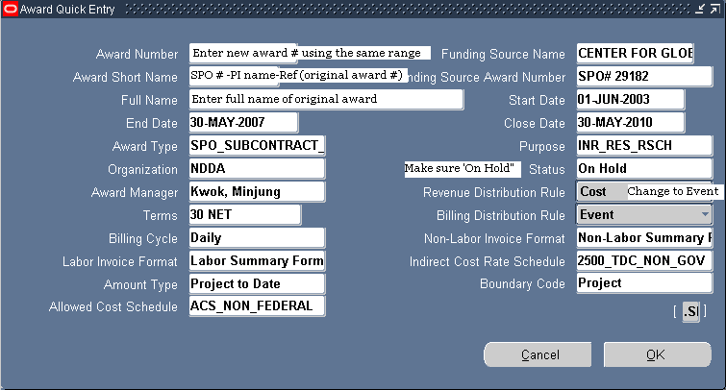

- Create a new installment
- In the installment description line type “Funding to generate revenue for (use original award #)”
- Check Active and Billable
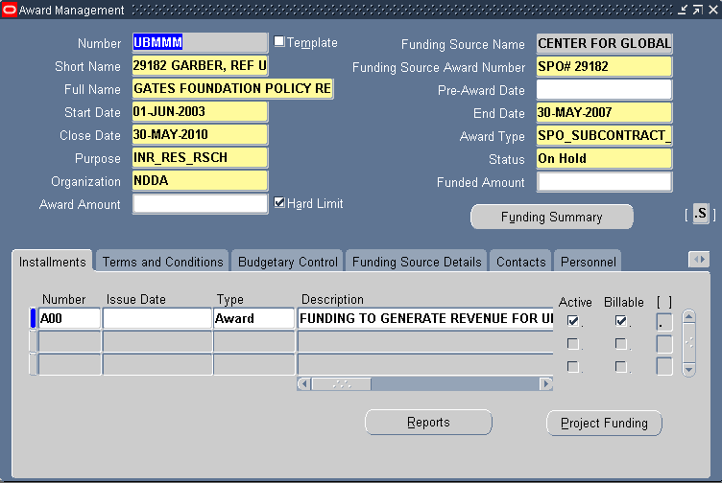

- Fund the project using the amount of unearned revenue to be generated.
- Use the original project number.
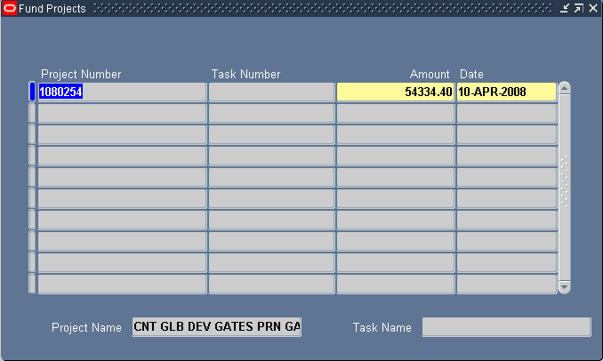

- Go to the Budgetary Control Tab and uncheck the ‘Enable Workflow for Budgets’ box.
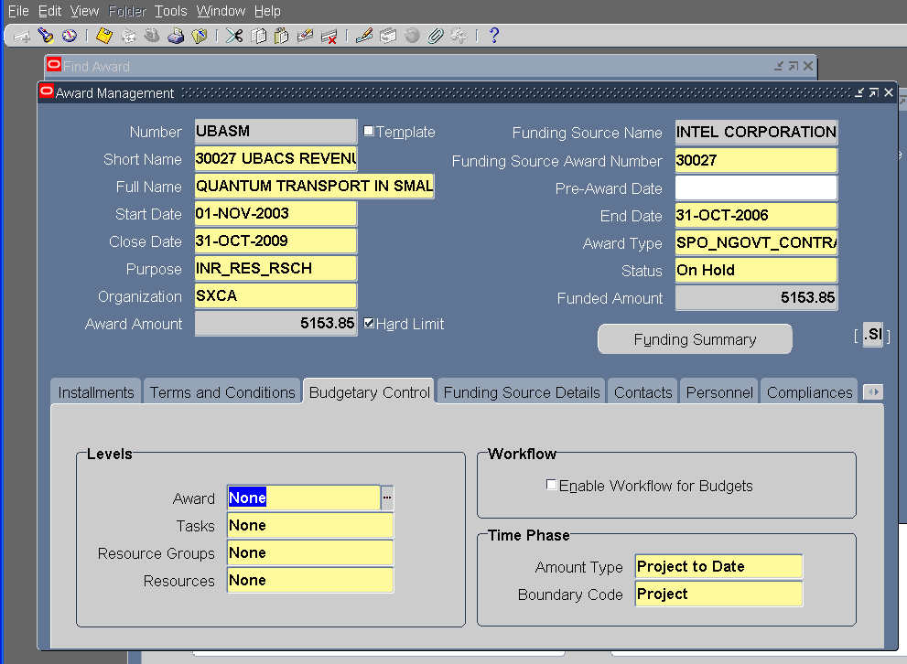
Uncheck Workflow

- Go to the Compliance Tab
- Click on the paper clip
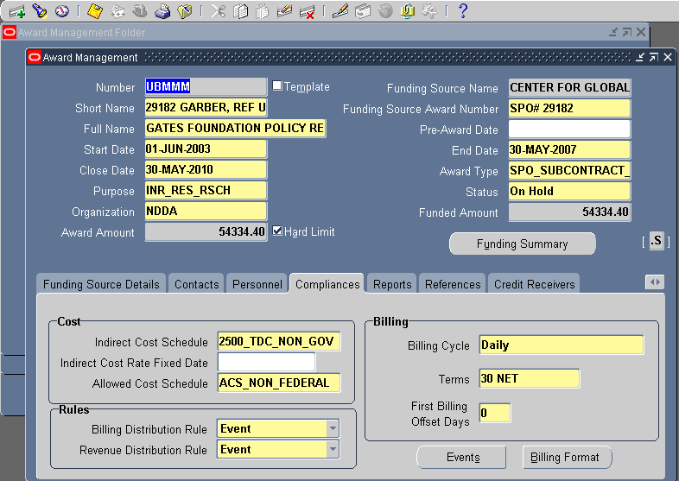

- Type information as seen below using the original award number
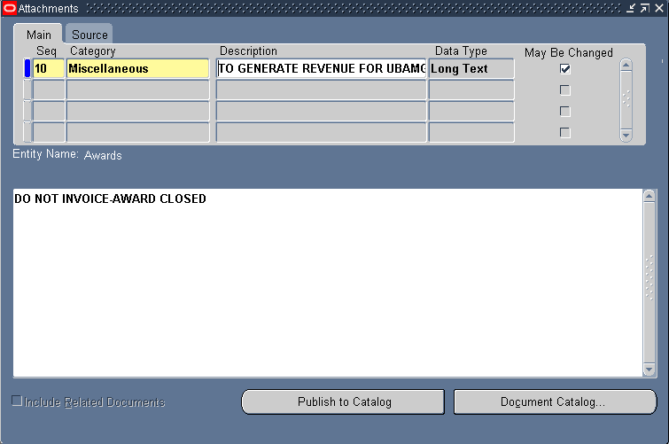

- Go back to the Compliance Tab
- Click on the Billing Format button
- Mark ‘No Print’
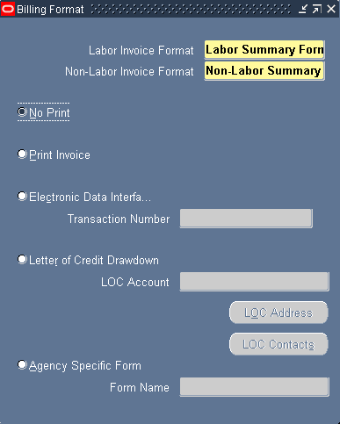

- Go to Award Budget
- In the Version Name and Description type in “FUNDING OF $ (use unearned revenue amount) TO GENERATE REVENUE FOR (use original award #)
- Budget at zero dollars
- Baseline
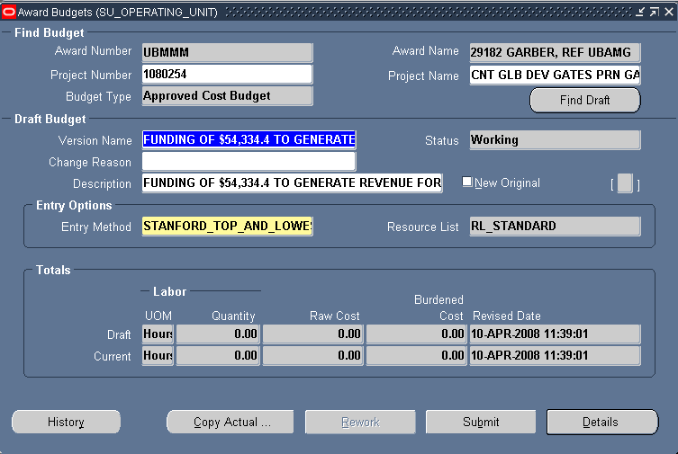

- Baseline and give award information to AR.

- On the original award in COFR, enter the new award in the Revenue Rec. Award field.
- On the new award in COFR, change the Close Out Status to “CWA Purpose”.

