

FFIT
Faculty Financial Inquiry Tool
Implementation Guide

http://ffit.stanford.edu

Version 1
September 17, 2009

Contents
1. FFIT Implementation Overview 3
2. Start Up: Access & Initial Data Quality 5
3. Assess & Develop Business Process Improvement 7
4. Prepare Materials and Roll Out to the Department 8

1. FFIT Implementation Overview

FFIT Implementation Process Overview
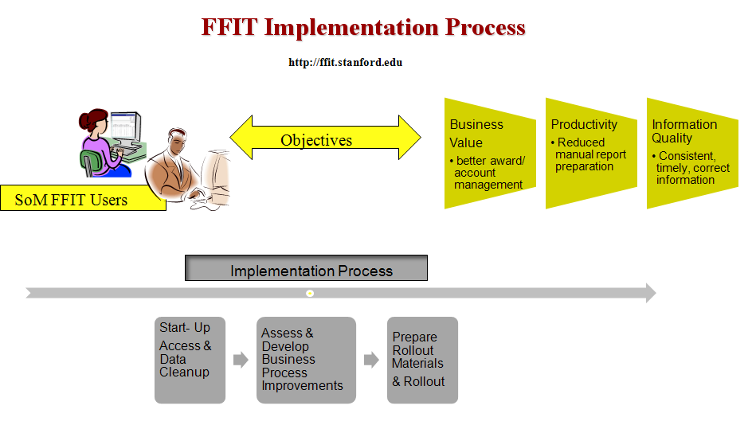

FFIT Description
- Helps faculty manage their University financial resources, which they own as individuals
- A faculty member can see all awards, projects and tasks which he/she owns
- Provides balances and drill-down transaction details for a faculty’s individually owned awards, projects, tasks
- Contains data that is refreshed daily
- Calculates balances using budget, revenue, expenditure and commitment data
- Provides online help in the form of tips and downloadable quick guides
- Optionally, shows allocations to others from the faculty member’s awards

Checklist: Steps to Implement FFIT
Each of these steps is expanded in sections below.
- Decide who will be responsible for data cleanup. Be sure this person fully understands the concept and implications of project, task and award ownership. Data cleanup involves reassigning incorrectly assigned award, project and task ownership, and closing certain awards.
- Obtain FFIT access for DFA’s and financial staff involved in data cleanup.
Email FFIT support (ffit-support@stanford.edu) and Sharon Reinbott (sharon.reinbott@stanford.edu), with your department name and org codes, and the names of any financial staff. Staff’s access to data in FFIT is controlled by Authority Manager.
FFIT Support will email you acknowledging your request, and Sharon Reinbott will send you your exception report for data cleanup.
- Contact FFIT support (ffit-support@stanford.edu) for assistance in data cleanup, or for questions.
- From exception reports, conduct data cleanup for the department. Instructions are located in the next section.
- Obtain FFIT access for faculty in your department.
Email FFIT support (ffit-support@stanford.edu), with your department name and request that FFIT be opened to your faculty. The owners of all projects, tasks and awards in your department will then be loaded into FFIT, and those owners will be able to see their financial resources.
Faculty access to data in FFIT is controlled by their being owners of awards, projects or tasks, in addition to their Authority Manager authority. You do not have to set any faculty up in Authority Manager for them to be granted FFIT access.
- Business Process Improvements: Assess the “as is” process; decide how FFIT might aid in improving the processes in your department.
- Consider rollout materials you might use, and any training you would like to do. You may decide to rely on the Tips and online job aids available from within FFIT. See the section on rollout below.

2. Start Up: Access & Initial Data Quality
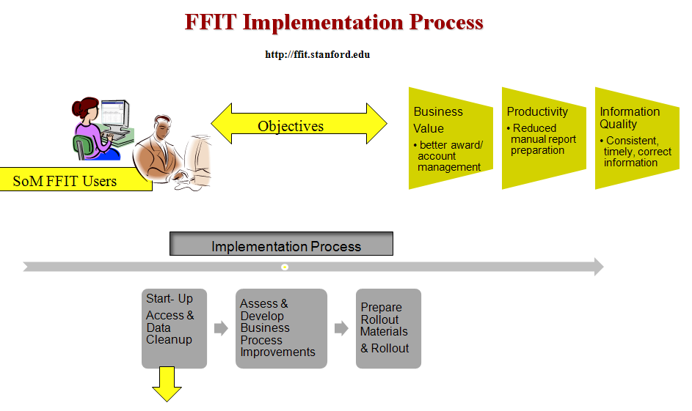

Understanding FFIT and how it grants
access, and ensuring data quality
will enable effective use of the tool
and reduce questions.

FFIT Job Aids
FFIT Quick Guide (job aid)
https://fingate.stanford.edu/docs/FFIT_quick_guide.pdf
FFIT Glossary of Terms
https://fingate.stanford.edu/docs/FFIT_glossary_of_terms.pdf

Obtaining FFIT Access
For staff: email FFIT support (ffit-support@stanford.edu) and Sharon Reinbott (sharon.reinbott@stanford.edu) with the name of your department(s), the org codes associated with it, and the names of any non-faculty financial administrators who should have access. Access will be based on the individual’s authority in Authority Manager.
FFIT support will email you with the notification that you have been granted access. Sharon Reinbott will send you a spreadsheet of exception reports.
For faculty: When you are ready to extend access to your faculty, email FFIT support
(ffit-support@stanford.edu) with the name of your department and a request to open FFIT access to faculty.
It is not necessary to set a faculty member up in Authority Manager for them to access FFIT, once they have been granted access.

Accessing FFIT at http://ffit.stanford.edu
- Go to ffit.stanford.edu
- Enter your SUNet ID and password
- Click “I agree to the above terms” at the end of the confidentiality agreement page, which appears next
- Choose a faculty member from the top menu labeled “Display Accounts For”
All awards, projects and tasks are organized under the owner’s name. To find any particular item, you must know its owner. There is no searching by such terms as organization, award number, project number or task.
You may advance the menu by typing all or part of the last name of the person you are searching for.
- Click on items in both the sponsored area at the top of the page and the non-sponsored area at the bottom of the page. Drill down as far as you can.

Conducting Data Cleanup in your Department
To avoid confusion, the data should be as clean as possible, to ensure that a faculty member’s inquiry result contains
- ALL data they should see; that is, all active awards, projects and tasks recorded in the accounting system as owned by the faculty member as an individual.
- ONLY data they should see; that is, only active awards that the faculty member owns.

The single most important issue is the coding of award owner, project owner and task owner.
Make sure you review all awards, projects and tasks for accuracy of this data.

- Be sure you have obtained exception reports for your department from Sharon Reinbott at sharon.reinbott@stanford.edu.
- Contact FFIT Support (ffit-support@stanford.edu) for assistance in reviewing and cleaning the data.
- PTA Owners and owning orgs (worksheets 1, 2): Since faculty can see all awards, projects and tasks which they own, be sure that these owners and owning orgs are correct. Review non-sponsored awards assigned to an individual when they should be owned generically (e.g., by DIRECTOR or CHAIR). Review non-sponsored awards to make sure the owner conforms to the fund authorization. Review sponsored PTA’s to ensure the PI and Co-PI are both represented appropriately in the ownership.
To make changes,
  - For non-sponsored PTA’s: contact Debbie Schuech, Associate Controller, School of Medicine at 650-723-5254 or Scheuch@Stanford.edu
  - For sponsored PTA’s: . Contact your Office of Sponsored Research contact person for your department. You can find the correct person at
http://ora.stanford.edu/ora/osr/contact.asp
- Non-Sponsored Awards: Close active non-sponsored awards with zero beginning balance (worksheet 3). Contact Debbie Schuech, Associate Controller, School of Medicine at 650-723-5254 or Scheuch@Stanford.edu.
- Cost Sharing Awards: Consider closing active cost sharing awards with zero beginning and ending balances and whose receipts + transfers = expense (worksheet 4). FFIT displays project to date budget, expenditures and commitments for these awards, and calculates a project balance, which sometimes does not relate well to the fund balance. This will confuse the award owner. Contact your Office of Sponsored Research contact person for your department. You can find the correct person at
http://ora.stanford.edu/ora/osr/contact.asp
- Sponsored Awards: Close active sponsored awards that have been closed out (worksheet 5). These active awards have a closeout status of COMPLETED or CLOSED, or their fund receipts, budget and expense are all within $100 of each other. Contact your Office of Sponsored Research contact person for your department. You can find the correct person at
http://ora.stanford.edu/ora/osr/contact.asp

3. Assess & Develop Business Process Improvement

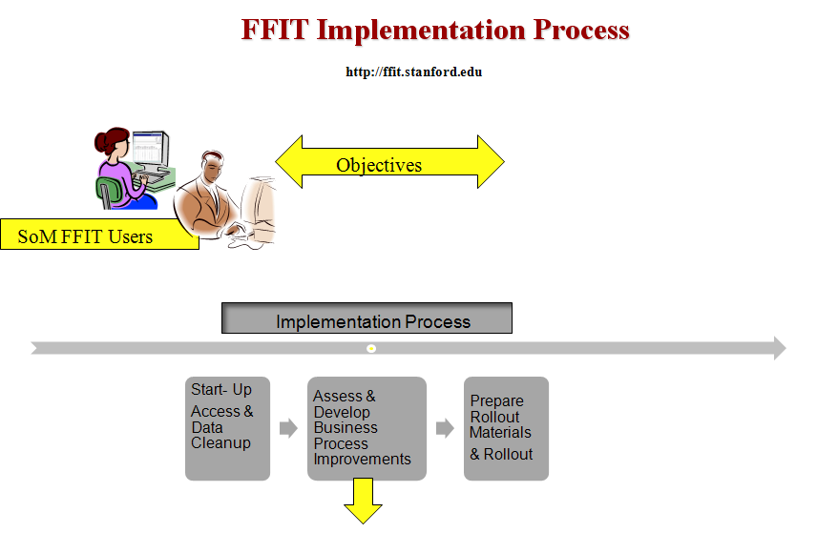

Implementation of FFIT provides the opportunity for
improving the efficiency and effectiveness of delivering
information to SoM departmental business users
and faculty.

Business Process Improvement Approach
The following items are a guide to thinking about the possible business process improvements you might be able to make in your department by using FFIT.

1. Evaluate the “As-Is” Process –
How is the equivalent FFIT information now being created and delivered and to whom?
- Where is the data derived from now?
- Who prepares the deliverables that contain this information now? How often? How long does it take?
- How is this information now communicated or delivered and to whom?
- How are questions about the information answered and by whom?

2. Design the “To-Be” Process – how can FFIT be used to eliminate/change the as-is process?
- Who besides the current information consumers could benefit from this information?
- Is the information available in FFIT sufficient to allow elimination of the current way this data is prepared? If not, what information in addition to FFIT will still need to be prepared and delivered? How and who will do this?
- What will be the on-going process for reviewing data quality and who will do this?
- How will the users get help and by whom?
- Who will document the new process for training purposes?

3. Monitor the results – Is the new process successful?
- How to determine and measure success?
- When and who does this monitoring?

4. Examples
- Manually prepared spreadsheets may be superseded by FFIT.
- FFIT may be able to replace local systems (e.g., Filemaker Pro, MS Access).

4. Prepare Materials and Roll Out to the Department

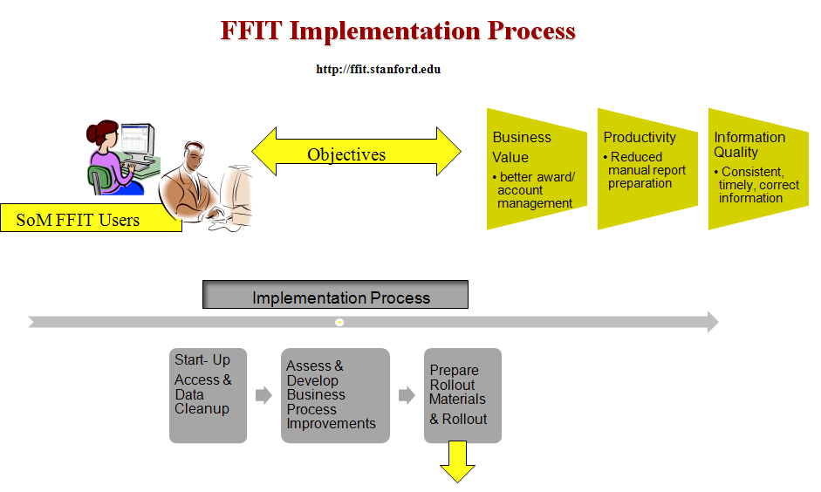

The adoption and effective use of FFIT by the
business end users will be dependent on the
relevance and availability of their rollout program.

Existing Rollout Materials

FFIT Job Aids
These can be obtained at the urls below, or they can be downloaded by clicking on “Need Help?” in the upper left of the FFIT pages.
FFIT Quick Guide (job aid)
https://fingate.stanford.edu/docs/FFIT_quick_guide.pdf
FFIT Glossary of Terms
https://fingate.stanford.edu/docs/FFIT_glossary_of_terms.pdf

FFIT Online Help
FFIT contains links labeled “Tip” in various places on each page. Clicking on the link provides the user with an explanation of the item in question.

FFIT Support
Contact FFIT Support (ffit-support@stanford.edu) for assistance in rolling out FFIT to your faculty.

1. Which approach, or combination of approaches, will work best for the end-users?
(Note: whichever delivery method(s) are chosen, it’s helpful to first conduct a pilot program of small, selected group of users that best represent the overall audience. This will help identify problems and issues with the method.)
- In-person, classroom type group sessions?
- Self-service online?
- One-on-one sessions?
- Other?
- Are different approaches required for different end user audiences?

2. What materials are required and who will prepare them?
- Rollout will need to encompass analysis and interpretation of FFIT data, use of FFIT tool, and process for support
- Based on the approach(es) selected, who will prepare and maintain any material?
- If formal training is chosen, who will deliver training, to which audiences? How often?
- Will training be required before the user can get access to FFIT? If so, who will monitor this process requirement?

3. Monitor the results – Is the training successful?
- How to determine and measure success?
- When and who does this monitoring?

